Verify and Confirm your QuickBooks Payroll Plan Subscritpion Status
- Open the Employee Center and Select the Payroll Tab.
- If the Subscription Status window displays “Verify Account,” select the underlined Verify.
- If you discontinued your payroll plan and chose not to participate in a plan, there will be no Payroll button.
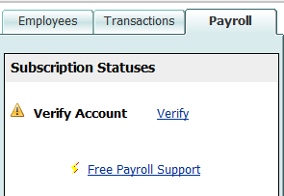
- If you switched from one plan to another plan, confirm that this was accomplished.

Or, in the Home page, select Payroll Subscription Alert.
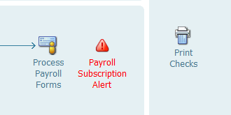
Confirm your Subscription Status
- Select Employees from menu bar
- Select Employee Center
- Select the Payroll tab

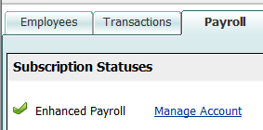
After Verifying your Subscription Plan, under the Payroll button, your subscription status should display either Basic Payroll or Enhanced Payroll.

