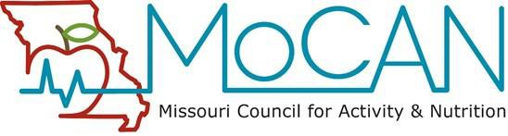

15th Annual MOCAN Healthcare Pre-professional Student Award “Excellence in Connecting Health to Community”

About MoCAN: The Missouri Council for Activity and Nutrition (MOCAN) is a coalition comprised of representatives from statewide and local agencies, institutions, organizations, other coalitions or individuals who work together to advance the goals and objectives of the statewide plan, Preventing Obesity and Other Chronic Diseases, Missouri’s Nutrition and Physical Activity Plan. See our MOCAN website
for more information.
Vision: The health and quality of life of Missourians will be significantly improved through healthy eating and active living.
Mission: MoCAN fosters and supports healthy eating and active living through policy and environmental changes to measurably improve the health and quality of life of Missouri residents.
Purpose of the Award: MOCAN’s Healthcare Workgroup seeks to recognize a healthcare pre-professional student in good standing who has demonstrated leadership in promoting an active living, healthy eating or other obesity prevention initiative in his/her MO community. Examples include, but are not limited to, Farm to School/Institution, Livable Streets and other initiatives supporting healthy lifestyles. By recognizing an outstanding pre-professional student who has enhanced patient care by impacting social, community and environmental factors related to healthy lifestyles, we hope to engage the broader community in supporting students, colleges and universities and community organizations to empower students to take an active role in obesity prevention. The recognized winner goes above, beyond and/or exceeds expectations set by academic requirements.
Evidence of Impact:
Successful applicants will provide demonstrated outputs of their activities related to connecting health and the community. Evidence of the impact the student has made will be identified through the application and/or through the letters of support.

Eligible Applicants: Students must be enrolled in an accredited higher education institution in MO and be in pursuit of one of the following degree types: MD/DO, PA, RN, LPN, BSN, MSN, ARNP, RD, PT/OT, Clinical/Medical Social Work or MA/PhD in a health-related profession, such as Psychology or Exercise Physiology.
Application Instructions: Students may self-nominate or be nominated by a colleague, supervisor or faculty member. A faculty member’s letter of support is required as part of the application. The application should be limited to 2 single-spaced pages, excluding letters of support (12 point font, 1 inch margins), and should contain the following elements:
- Nominee Name, Contact Information, College/University, Degree Program, Anticipated Date of Graduation
- Nominator Name, Relationship to Nominee and Contact Information
- Description of the Project, including student’s leadership role, time and effort investment, participation in collaboration, and impact on student, target audience and community
- Letter of support (in addition to the application)from faculty member at student’s institution (required only if nomination is not initiated by a faculty member) describing student’s role
- Optional: Letter of support from community member (in addition to the application) describing impact of student’s role
- Optional: Three to 6 photographs and/or brief (<3 minutes) video of the project
Please submit application electronically to:
Julie Benard, MD
dr_julie_ann@yahoo.com

Deadline for submission: Application and supporting materials must be received by Friday, June 5, 2026.
Questions: Please contact Julie Benard, MD at the email address above.

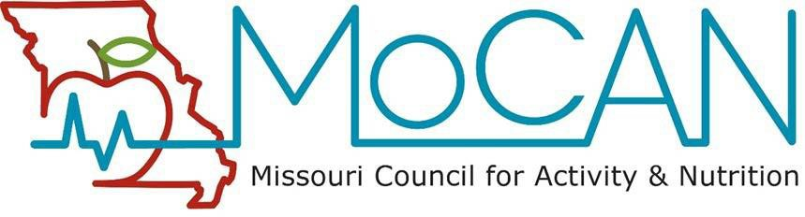

15th Annual MOCAN Healthcare Pre-professional Student Award Application “Excellence in Connecting Health to Community”

- Nominee Name:
- Nominee Contact Information:

- Nominee College/University, Degree Program, Anticipated Date of Graduation

- Nominator Name:
- Nominator Contact Information:

- Nominator Relationship to Nominee:
- Description of the Project, including student’s leadership role, time and effort investment, participation in collaboration, and impact on student, target audience and community:

- Letter of support (in addition to the application) from faculty member at student’s institution (required only if nomination is not initiated by a faculty member) describing student’s role
- Optional: Letter of support from community member (in addition to the application) describing impact of student’s role
- Optional: Three to 6 photographs and/or brief (<3 minutes) video of the project

