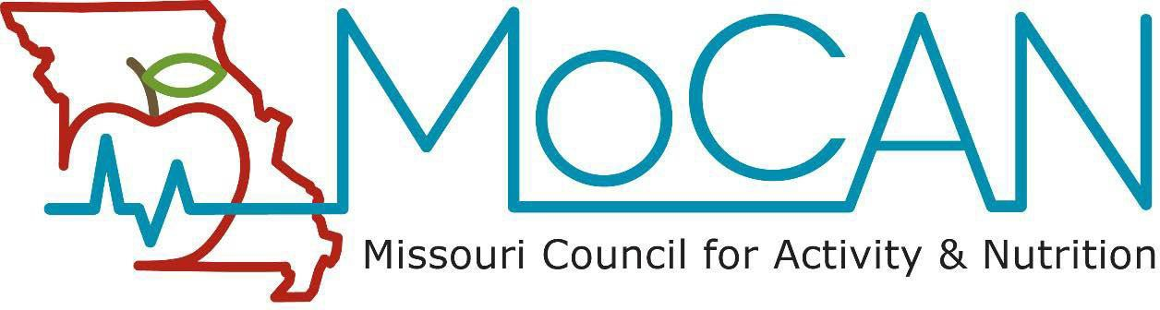

15th Annual MOCAN Healthcare Professional Award “Excellence in Connecting Health to Community”

About MOCAN: The Missouri Council for Activity and Nutrition (MOCAN) is a coalition comprised of representatives from statewide and local agencies, institutions, organizations, other coalitions or individuals who work together to advance the goals and objectives of the statewide plan, Preventing Obesity and Other Chronic Diseases, Missouri’s Nutrition and Physical Activity Plan. See our MOCAN website for more information.
Vision: The health and quality of life of Missourians will be significantly improved through healthy eating and active living.
Mission: MOCAN fosters and supports healthy eating and active living through policy and environmental changes to measurably improve the health and quality of life of Missouri residents.
Purpose of the Award: MOCAN’s Healthcare Workgroup seeks to recognize a healthcare professional who has demonstrated leadership in promoting an active living, healthy eating or other obesity prevention initiative in his/her community. Examples include, but are not limited to, Farm to Institution (such as Farm to School), Livable Streets or other initiative supporting healthy lifestyles. By recognizing an outstanding healthcare professional who has enhanced patient care by impacting social, community and environmental factors related to healthy lifestyles, we hope to engage the broader community, including healthcare colleagues and institutions, in supporting healthcare professionals to take an active role in obesity prevention.
Evidence of Impact: Successful applicants will provide demonstrated outputs of their activities related to connecting health and the community. Evidence of impact the professional has made will be identified through the application and/or through the letter of support.
Eligible Applicants: Healthcare professionals must practice in the state of MO and may represent the following specialties: MD/DO, PA, RN, LPN, BSN, MSN, ARNP, RD, PT/OT, Clinical/Medical Social Work or MA/PhD in a health-related profession, such as Psychology or Exercise Physiology. Healthcare professionals must be in good standing within their practice setting.

Application Instructions: Healthcare professionals may self-nominate or be nominated by a colleague. Please see the attached application form. The application should be limited to 2 single-spaced pages (12 point font), and should contain the following elements:
- Nominee Name, Degree, Contact Information, including clinical or academic setting
- Nominator Name, Relationship to Nominee and Contact Information
- Description of the Project, including healthcare professional’s role, time and effort investment, participation in collaboration, impact on target audience and on community
- Optional: Letter of support from community member describing impact of healthcare professional’s role
- Optional: Three to 6 photographs and/or brief (<3 minutes) video of the project
Please submit application electronically to: Julie Benard, MD at dr_julie_ann@yahoo.com

Deadline for submission: Application and supporting materials must be received by Friday, June 5, 2026.
Questions: Please contact Julie Benard, MD at the email address above.

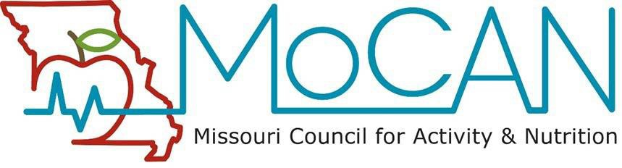

15th Annual MOCAN Healthcare Professional Award Application “Excellence in Connecting Health to Community”

- Nominee Name, degree and current position:

- Nominee Contact Information:

- Nominator Name:
- Nominator Contact Information:

- Nominator Relationship to Nominee:
- Description of the Project, including nominee’s leadership role, time and effort investment, participation in collaboration, and impact on target audience and community:

- Optional: Letter of support from community member (in addition to the application) describing impact of healthcare professional's role
- Optional: Three to 6 photographs and/or brief (<3 minutes) video of the project

