GETTING STARTED WITH QUALTRICS
FOR ESIP DATA COLLECTION

For Extension Specialists

As part of the University of Missouri, you have access to special Qualtrics accounts and features that can assist with your Eat Smart in Parks (ESIP) data collection. Not only does this make data collection faster and easier, but it also allows for more robust reporting and data analysis to assist parks in determining park patrons’ attitudes and preferences when it comes to healthy food options. The data collection can also be used in completing your Extension reports.

Let’s get started!

Existing Qualtrics surveys for ESIP include:
- Customer healthy park concessions attitudes and preferences
- Food taste testings
- Follow up customer surveying
- Park concessions observations

All of these surveys can be downloaded to your iPad or mobile device, and be customized for your park(s). You will need internet connection to download the survey. But you do not have to be connected to the Internet while in the park to do this data collection. Use of the Qualtrics Offline App will record the data you collected and once you return to wireless or an Internet connection these results can be uploaded to the Qualtrics server and saved in your account. . (Please note, other Extension programs using the Qualtrics Offline App may have procedures that differ slightly from ESIP’s procedures.)

STEPS FOR USING THE EAT SMART IN PARKS QUALTRICS SURVEYS

Preparation steps:
- Make sure you have a Qualtrics account and that your account has been enabled for use with the Offline App. If you are unsure if you have an account or need an account, contact Steve Williams, IT manager, williamssa@missouri.edu. The logon for Qualtrics is https://missouri.qualtrics.com
- Determine how many iPads/kiosks you need. If you are surveying during a large event, 4-5 should work. For smaller events 2-3 kiosks would suffice.
- Obtain the iPads that you will use. IPads are available from:
  - Campus:
There are 12 iPad kiosks on campus that can be checked out. Contact Cindy DeBlauw at deblauwc@missouri.edu to check out kiosks.
- FNEP Regional Extension offices.
Each Extension FNEP Coordinator has 2 iPad kiosks that can be checked out. Contact the FNEP Coordinator in your region to check out the regional kiosks.
- Any iPad can be used as long as the Qualtrics App is installed.
- Be sure that each iPad is up to date with the latest software.
5. Be sure each iPad has the Qualtrics Offline app downloaded. [Note: if the offline app has NOT been downloaded, you will need to download it through the iTunes/App store. Steve Williams, IT manager for HES Extension can walk you through this process if needed.] For iPads with Qualtrics Offline already downloaded be sure that it is up to date. .
6. Request the surveys you need from Cindy DeBlauw at HES Extension (deblauwc@missouri.edu). Review the surveys and identify changes needed to customize the surveys for your parks. Send your survey changes to Cindy. She can modify and share the appropriate surveys with you and your Qualtrics account. Turn on the iPad and get connected to the Internet or wireless. You will need an Internet connection to download the surveys you will use in the field.
- On the iPad, access the Qualtrics website by opening the web browser (Safari). Go to http://missouri.qualtrics.com and enter in your pawprint and password information.
- Next you will generate a token to load the mobile offline app surveys. To generate a token, first click on your name in the upper right hand side of the screen to access the drop down menu.

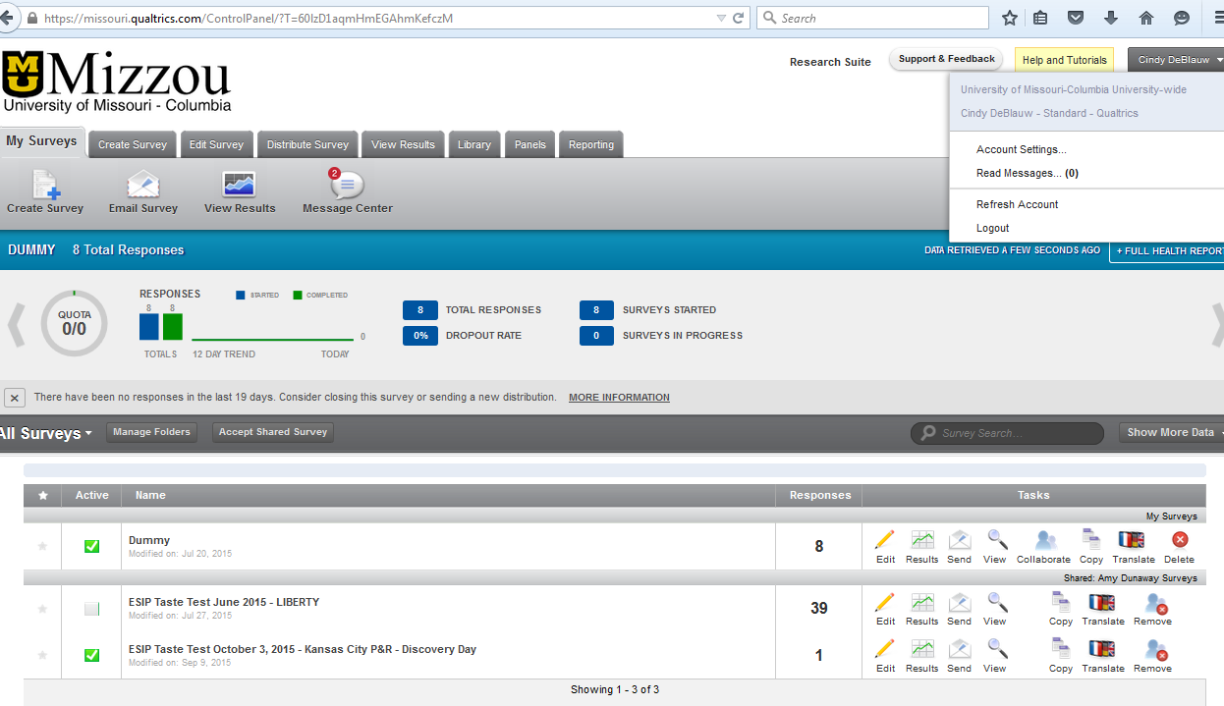
Step 9
Step 8
- In the drop down menu, select “Account Settings”.
- On the “Account Settings” page select:: “Qualtrics IDs”
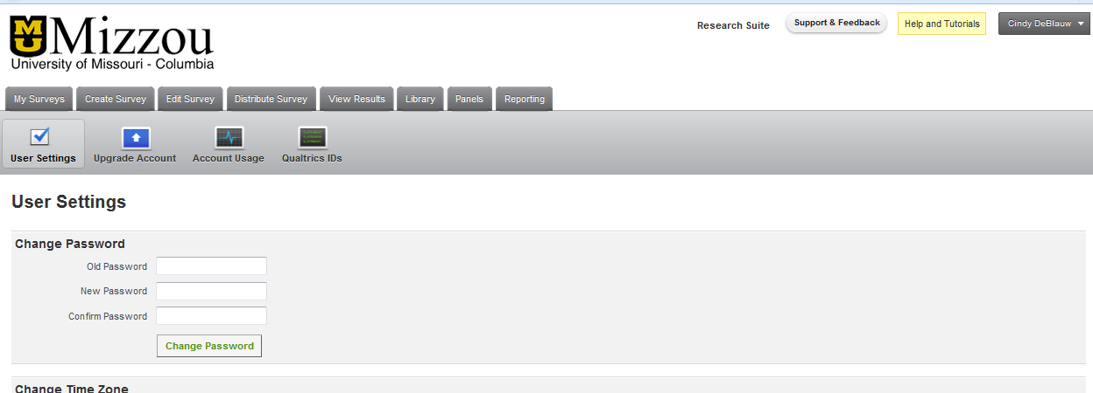

- On the “Qualtrics IDs” page, under the “API section,” click on “Generate Token”. This is a unique token to you and will need to copy this and use it to set up every iPad or mobile device you need for the field surveys.
Note: If “Generate Token” is greyed out, this means your account has not been enabled for the offline Qualtrics App. Contact Steve Williams williamssa@missouri.edu
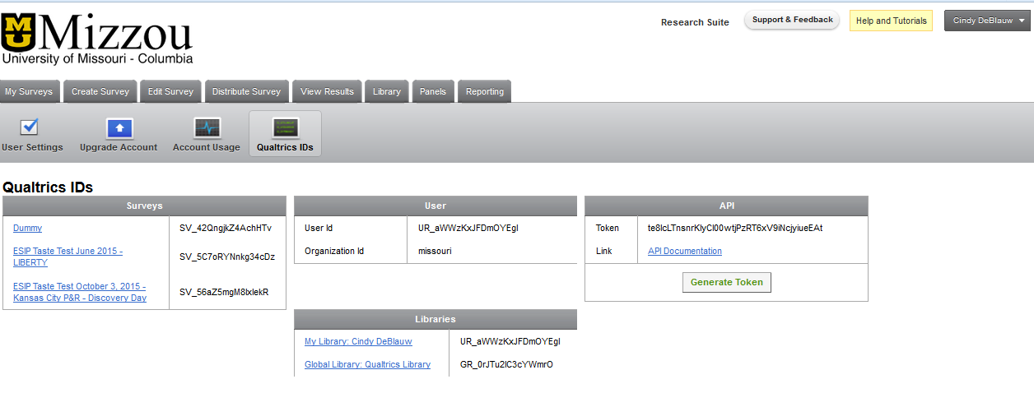
- Now open up your Qualtrics offline app on the iPad device you will be using for offline data collection.

- Access the log in screen by clicking on the “Gear” in the upper right hand corner of the page.

- Double-tap the user picture/circle icon twice to see the Username and Password fields and to also reveal a third field, “API Token.” The API Token field will be seen underneath the ‘password’ field. This “API Token” field is where you paste in the unique token you generated earlier. This token is unique to you and you can use the same token on each device you need for the field. Make sure you enter in your pawprint, but please note, the format will be your PawprintName#Missouri. Then tap the “Save” button to log on. Note: to reveal the “Save” button, you will need to tap the Keyboard icon on the lower-right corner of the keypad. This moves the keyboard out of your way.

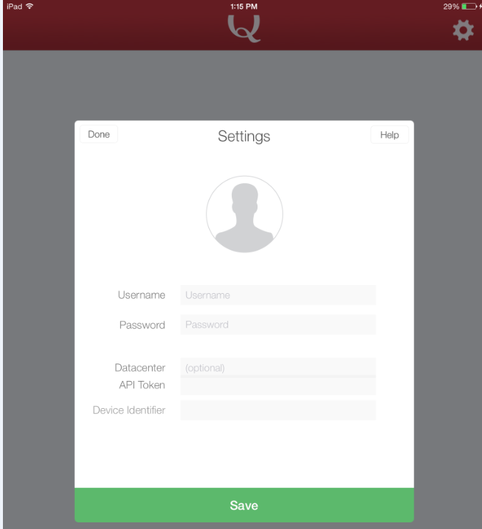
Double tap user circle icon TWICE to reveal API field
Enter token
Leave password field blank

Pawprintname#missouri (no spaces)

Click the “Save” button

- Once you are logged in, you should be presented with one or more surveys that you can download to the device. Tap the survey you want to download. Then complete the download by clicking the green “Download Survey” bar. 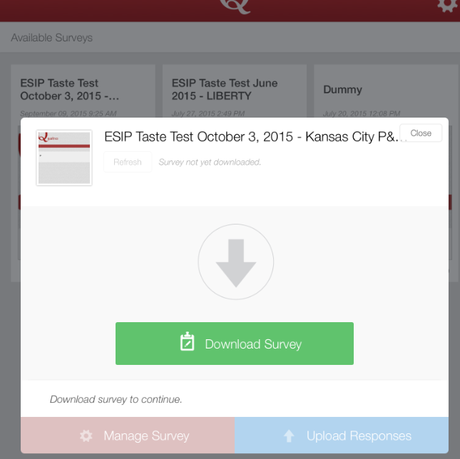

- If you have requested changes be made to the survey after it has been originally downloaded to an iPad, you will need to refresh the survey on the Qualtrics app. This means that iPad will need to be connected to Wireless or the Internet in order to download the updates. The “refresh” button is in the top left of the survey dialogue box, just below the title of the survey. Please note: Even when Qualtrics refreshes every time you launch, if you don’t refresh the individual survey, it WILL NOT refresh the individual survey’s changes.
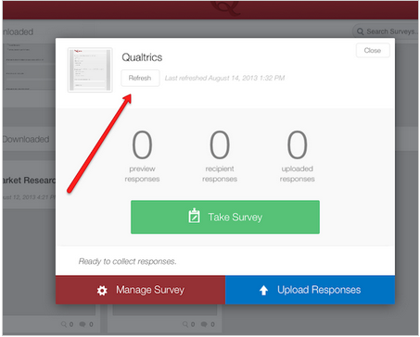
Photo credit: Qualtrics.com

- To launch your survey, click the green “Take Survey” button. You can turn on the “Kiosk Mode” if you do not want the ‘x’ close button to appear in the top right of the surveys, and if you want the survey to start over after a period of inactivity. [Note: To exit kiosk mode once enabled, double tap the screen with 3 fingers and the ‘close’ button will reappear.]
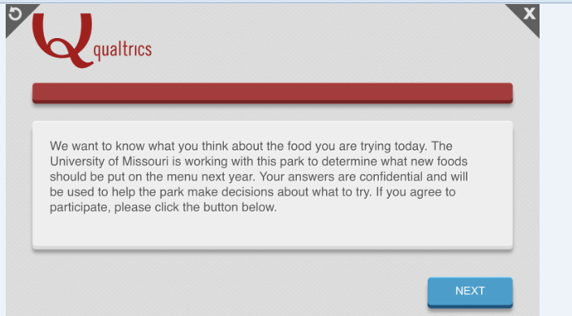
Click “x” to turn on kiosk mode
- Once you are done collecting data, close Qualtrics, or simply return to your “Home” screen on the iPad.
If you experience any trouble or problems with the data collection, please make a note of them. Please share the feedback with Cindy DeBlauw when you are able, as this will help improve the experience for other Extension Specialists in the future.

To Upload the Qualtrics Offline App Data to Qualtrics/Extension Database
- Make sure you have Internet or wireless connection. Turn on the iPads and open the Qualtrics app.
- Click on the survey you wish to upload data for and click on the blue button, “Upload Responses”.
- Let Cindy DeBlauw know when you upload your responses and how many survey responses you should have. She will verify the number uploaded with your report in her Qualtrics account.
- Sometimes the Qualtrics Offline App will not appear to update the responses, or it will appear as if not all the responses have been updated or sent to the server. This is an issue with Qualtrics Offline that we have reported back to the company. We hope future updates of the app will address these small glitches. This is why it is important to confirm the upload of data with Cindy.
- When you are done collecting and uploading data, let Cindy know to close the survey. This will ensure that no more data is entered into your survey mistakenly.
- Qualtrics has robust reporting features within the regular online Qualtrics account. You should be able to see these reports under “Results” when you log into Missouri.Qualtrics.Com. Please let Cindy know when you wish to know more about the data or if you have any data analysis needs.

Additional Considerations:
- When using the iPads in the field, you may need someone nearby to assist patrons who are unfamiliar with the iPad and/or online survey.
- Make sure your iPads and backup batteries are charged up before your event.
- It can be helpful to set up the iPad kiosks under a tent or shady spot to ensure that patrons can see the screens well. A tent or overhang will also help if the weather is unpredictable.
- If you want to survey using both iPads and a paper-based survey, you can have someone enter in the paper-based survey data at a later date. If you wish to do this, please let Cindy know in advance to make sure the online and paper-based surveys are set up correctly.
- If you know your park or rec center wants to participate, you can add your park to our current ESIP research study. This will require getting a signed permission letter from the park’s administration BEFORE you actually begin any survey work. Please let Cindy or Kim Keller know as soon as possible.

