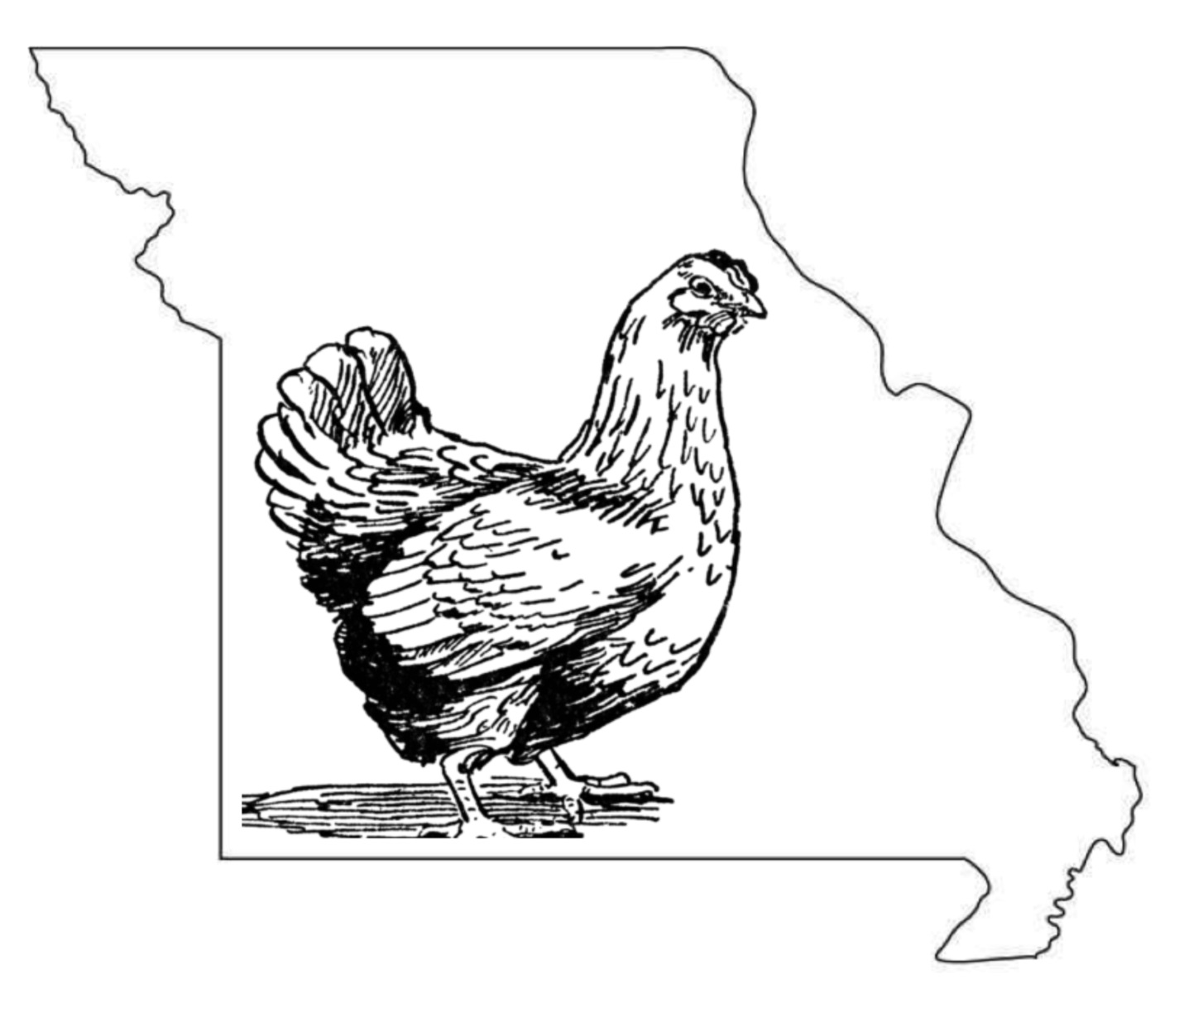
Member Name________________________________________________________________________
Address _______________________________________________________________________________
City, State, Zip ________________________________________________________________________
Name of 4-H Club ____________________________________________________________________
Birth Date ___________________________ Phone _________________________________________
4-H Project Record Book
Introduction
This project record book has been created specifically for 4-H members enrolled in a poultry 4-H project. Keeping a record book is an important part of the project. It will help you set goals for the project year, record your accomplishments, and provide a place to keep important records on your poultry.
What is a 4-H project?
A project is a subject or topic that you learn about in 4-H. In this case, your project is poultry. You learn about your project by attending club meetings and educational workshops, and working with adult leaders and other 4-H members. You can also learn from field trips and by participating in shows and competitions.
Why complete a record book?
A record book is not meant to be a chore. Instead, it is a way for you to learn about your project, as well as other valuable skills such as setting goals, collecting information, evaluating information, tracking cost and expenses, organization, and others.
The record book can be three-hole punched so that is may be easily kept in a 3-ring binder. Your 4-H poultry records should be accumulative – meaning that you keep and add to your records from year to year, keeping them all in a 3-ring binder or portfolio. You can organize your notebook however you choose. Some 4-Hers may anticipate having the same project animal for more than one year. In this case you might choose to organize your notebook by project animal and will simply continue to add information and pages to your records for that animal over the years.
This is just an example of one way that you might organize and present your 4-H Poultry project records. But, remember – these are YOUR records and part of the goal for completing them is that you use your imagination and be creative in how you develop them. The idea is that as the completion of your 4-H career, you will have a compilation of records that shows your progression in your project from year to year.
Project Goals (at start of project)
State at least 3 goals at the beginning of your 4-H project year. Tell the things you want to learn from you 4-H Poultry project. Please discuss these goals with your parents and your 4-H leader. (Example: Learn how to do poultry showmanship, participate in avian quiz bowl, etc.)
- __________________________________________________________________________________________________________________________________________________________________________________________________
- __________________________________________________________________________________________________________________________________________________________________________________________________
- __________________________________________________________________________________________________________________________________________________________________________________________________
Member Signature: ___________________________________________
Parent Signature: _____________________________________________
Summary of Accomplishments (when record book is due)
What goals have you accomplished? If you have not accomplished one or more of your goals, please explain. What have you learned? Describe your experiences this year. (Attach additional paper if needed.)
______________________________________________________________________________________________________________________________________________________________________________________________________________________________________________________________________________________________________________________________________________________________________________________________________________________________________________________________________________________________________________________________________________________________________________________________________________________________________________________
Member Signature: ___________________________________________
Leader Signature: _____________________________________________
Poultry Inventory Record
Use one chart for all project birds at the beginning of the project year. Add pages if necessary.
Animal ID  (Band/Name) | Description  (Breed, Variety) | Date of Hatch | Sex | Ownership Information | Purchase Price | Value*
- Raised
- Purchased
(date)_________
- Raised
- Purchased
(date)_________
- Raised
- Purchased
(date)_________
- Raised
- Purchased
(date)_________
- Raised
- Purchased
(date)_________
- Raised
- Purchased
(date)_________
- Raised
- Purchased
(date)_________
- Raised
- Purchased
(date)_________
- Raised
- Purchased
(date)_________
- Raised
- Purchased
(date)_________
- Raised
- Purchased
(date)_________
- Raised
- Purchased
(date)_________
- Raised
- Purchased
(date)_________
*The price you would ask if selling the bird.

Animal Care and Management
Your project requires regular care and management. List the things necessary to take care of your project animal(s).
Include the following:
- Feeding and watering practices
- Egg Handling
- Health practices and medicines
- General Management (cleaning living area, etc.)
Daily – Things done once or twice a day
Weekly – Things done once or twice a week
Monthly – Things done once or twice a month
Yearly – things done one time or occasionally throughout the year

Equipment and Supply Inventory
At the beginning of the 4-H year take an inventory of what equipment and supplies are on hand.
Add new equipment or supplies you purchase to the list. Estimate a cost value for any shared equipment. (Example: 1 set of nail clippers shared between 3 members, $21.00/3=$7.00 each member).
Qty. | Item Description | Already Owned or Purchased | Purchase Price
1 | Example: Poultry pen | Already Owned | $0
4 | Example: Feed bowls | Purchased | $3.00 (=$12.00)
 |  | Total Value | $

Feed Records and Expenses
Keeping food feed records is important. Good records show your expenses for feed and what kind of feed you use for your project. A good practice is to enter your feed expenses when you buy feed. At the end of each month or at the end of a particular flock or management phase, total each kind of feed used and its cost and record the information below. Home-raised feeds or feed available as payment for other farm labor performed should be valued at market price – what it can be sold for. Include that as the value in the record. Duplicate these pages if needed for more detailed records by groups.
Type and Cost of Feed Used
Date of Purchase | Amount Purchased (LBS) | Type of Feed  (grain mix, pellets, mineral, supplement) | Cost or Value
Total Pounds |  | Total Feed Cost | $

Feed Tag Information
Please attach a tag or label from one feed being used for your project animals.
If a homemade mix is used please describe the mix on the back of this page.

- What is the main ingredient in this feed?

- How much of this product do you feed daily? (to all birds)

Describe your feeding program in detail:
Poultry Health Record
ID # | Breed | Sex | Age | Illness or Symptoms | Treatment | Treatment Date

Health Care Expenses
Treatment | Treatment Date | Medication Cost
 | Total Health Care Expenses | $
Poultry Death Record
ID # | Breed | Sex | Age | Date of Death | Cause

Poultry Management Records

Monthly Laying Record

Month | # Eggs Produced | # Eggs  Home Use | # of Birds | % Production*
Totals

*Percent Production = # Eggs Produced
# of Birds

Poultry Incubation Records
Incubation Records
Date Set | #  Eggs Set | Date Hatched | # Eggs Fertile | %  Fertility | # Hatched | % Hatched | % Hatchability*
*Hatchability = # eggs fertile
# eggs hatched

Poultry Management Records
Egg Sales
Date of Sale | # Dozen Eggs Sold | Customer Name | $  Amount Sold
 |  | Total Amount | $

Miscellaneous Expenses or Fees
List any expenses that do not fit into one of the previous categories.
Date | Description of Expense | Cost $
 | Total Miscellaneous Expenses | $

Miscellaneous Income
List any income from the sale of products other than eggs from your Poultry project.
Date | Description of Income | Income $
 | Total Miscellaneous Income | $

Poultry Show Record
Name of Show | Show Date | Entry Fees | Placing | Breed, Variety, Band # Entered | Premium Amount
Total Entry Fee  Cost |  | $ |  | Total Premiums Won | $

Project Financial Summary
One goal of the poultry project is to teach budgeting, marketing and money management skills. The following chart will help you evaluate the financial status of your project.
Income | Totals
Egg Sales (pg. 13)
Miscellaneous Income (pg. 15)
Show Premiums (pg. 16)
Total Income | $
Expenses | Totals
Purchased Animals (pg. 4)
Equipment Expenses (pg. 6)
Feed Expenses (total of all pg. 7 records)
Health Expenses ((total of all pg. 9 records))
Miscellaneous Expenses (pg. 14)
Show Expenses (pg. 16)
Total Expenses | $
Financial Summary (Total Income – Total Expenses = ) | Profit/Loss  (circle one)

- Was the cost of keeping your project what you expected?

- What (if anything) will you do differently next year?

