Examples of items subject to disqualification at the Missouri State Fair
Project/Item | Acceptable | Not Acceptable
Cakes | Use royal icing or fondant. Tag is placed on the cake plate.  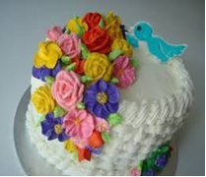 | 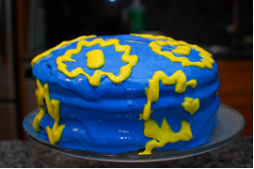  Do not use buttercream frosting (it melts) or place the tag directly on the cake.
Multiple item projects (i.e. Shopping in Style) | Pick the “best” item that reflects your project. Place the tag on the front of the item.  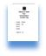  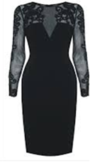 | Do not send more than two pieces of an item as they can easily get separated.  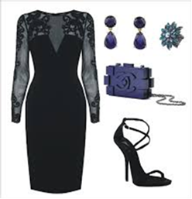
Baked items or produce | Put food items on clear plastic plates.  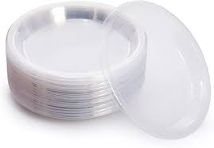 | 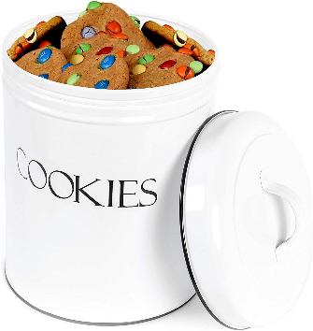  Do not place items in expensive or keepsake containers.
Posters | Posters should be 14x22 inches.  14 inches  22 inches | Do not send posters larger than 14x22 inches.  28 inches  44 inches
Notebooks | Send one page in a protective sleeve that best represents the notebook.  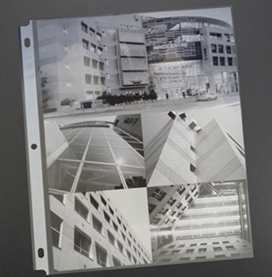 | Do not send projects that are contained in a 3-ring binder, folder, or portfolio.  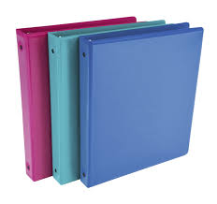  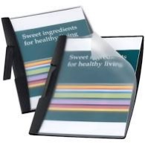  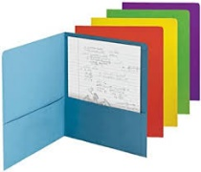
Scrapbooks | Send one page in a protective sleeve that best represents a scrapbook. | Do not send an entire scrapbook.  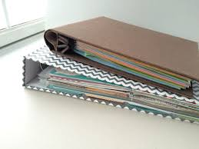
Educational Displays | Educational displays may be up to 12 inches in height, length, and width.  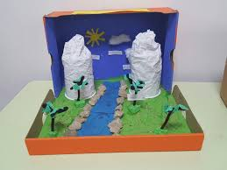 | Do not send educational displays that exceed the size limit.  