Sample Photographs of Acceptable versus Disqualified State Fair 4-H Exhibits
Project item  and rule | DO |  | DON’T
Cakes – royal icing only, fondant etc…  Fair tag is visible. | 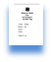  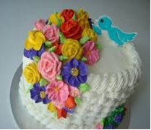 |  | 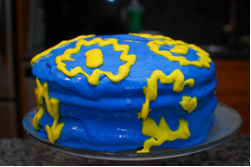
 | Use royal icing or fondant.  Do place tag on front of cake. |  | Buttercream frosting melts.
Project item & rule |  | DO |  | DON’T
Multiple item projects (e.g., Clothing you Buy) – Limit your State Fair exhibit to 1 or 2 pieces that represent the set.  Fair tag is visible. |  | 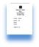  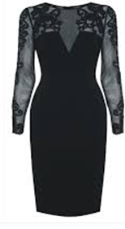 |  | 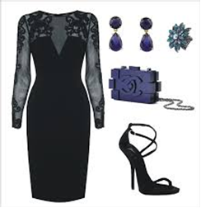
 |  | Do pick the “best” item that reflects your project. Do place a fair exhibit tag on the front of the article, even if you have another one pinned inside or under the item. |  | Too many pieces will get separated.
Project item & rule |  | DO |  | DON’T
Baked or produce items… |  | 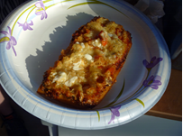 |  | 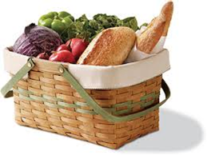
 |  | Put food items on paper or disposable plates. |  | Wrap and put in your treasured Longaberger basket or Aunt Shirley’s favorite dish. Food items are removed from containers as soon as they arrive at the fair.

This document is only intended to convey the initial concept of a visual 4-H exhibit guidelines document.
It should not be referenced in any way as a reference for any county or state fair exhibits.

