Missouri 4-H
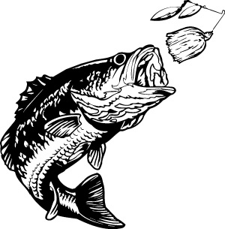
State Sportfishing Day

June 1, 2019
Little Dixie Lake Conservation Area
(near Fulton, MO east of Columbia http://mdc.mo.gov/a5904 )

- Fishing Derby
- Casting Contest
- Skill-a-thon
- Lunch
- Educational Demonstrations/Community-based Service Learning

EVENTS
Prizes awarded in 3 age divisions for all events
Junior: 8–10 yrs. Intermediate: 11-13 yrs. Senior: 14 & older

- Fishing Derby Check-in: 7:30 – 8:00 a.m. Orientation: 8:00 – 8:15 a.m.
Fishing begins at 8:30 Concludes at 11:00 a.m.
Immediately following the fishing derby are the other 2 events

- Casting Contest
Accuracy - use your own rod & reel and a practice plug (no hooks)

- Skill-a-thon (skills & knowledge)
May include any or all of the following

- Fish identification
- Missouri fishing regulations
- Terminal rigging
- Tackle identification
- Matching tackle to fish

- Basic fish biology
  - Habitat preferences
  - Identify fish parts
- Aquatic Ecology
- Fishing safety
- Sportsman ethics
- Lunch approximately Noon

- Educational Demonstration approximately 1pm

- Recognition immediately following Educational & Research Demonstrations
A Gift card from Bass Pro Shops and goodies for all registered participants.

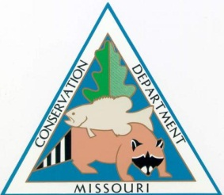
Sponsored by Bass Pro Shops with generous support from the Missouri Department of Conservation
Special Thanks to the many volunteers assisting in the event.

MORE DETAILS ABOUT THE EVENT:
For information on MDC Dixie Lake Conservation Area: Do an internet search or go to:
http://mdc.mo.gov/a5904

Fishing Derby Rules:
- Participants 8-15 years of age must be accompanied by an adult in close proximity during the fishing derby. (4-H age)
- Youth 16 years of age and older may participate without an adult…unless fishing from a boat.
- All boats must be piloted by an adult. And must not have not more than 3 youth per boat.
- Fish will be measured for score at the time of the catch. Tournament scoring is based on fish length. Fish will be measured, verified by the accompanying adult and may be returned to the water or kept by the fisherman; in accordance with MDC regulations.
- Each eligible fish will be scored on a “point per inch” formula that attempts to equalize the differences between species.
See chart here: http://4h.missouri.edu/go/projects/sportfishing/conversionchart.pdf
- Eligible fish species are any legal fish species listed on species/point conversion table. Minimum length of 4” to qualify for official score.
Youth may measure every fish caught but no more than the daily legal limit will be used for official scoring.
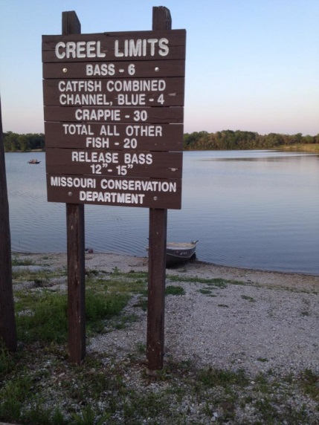
- All state MDC regulations and specific regulations for Little Dixie CA must be observed.
- Daily limits are six black bass, four catfish in aggregate (channel or blue) and 30 crappie. All other fish may not exceed 20 in the aggregate.
- Black bass between 12 and 15 inches must be returned to the water unharmed immediately after being caught. (But can count for score)
- Seining or trapping live bait, including tadpoles, is prohibited in lakes and ponds.
- Boats, including sailboats, may be used on lakes and ponds designated as open to boats. Boats may not be left unattended overnight.
- Outboard motors in excess of 10 horsepower must be operated at slow, no-wake speed.
- Fishing license required for youth 16 years of age and older.
- Youth are limited to fishing with 1 pole (rod & reel outfit) at a time.
- Use of Missouri Department of Conservation boats are prohibited. We are using a public area and out of courtesy to others we do not permit the use of MDC boats on site. You can bring your own boat and trailer however there is not a separate class for boats.
- Safety:
- All participants are required to follow 4-H guidelines and must wear long-billed cap, visor or hat AND eye protection (sun glasses or prescription glasses) while fishing.
- Fishing participants must wear life jackets when in the boat.
- Adult Intervention:
The sportfishing program is designed to teach basic fishing skills – so participants are expected to tie on their own hooks/lures, bait their own hook, cast their own rod/reel, land their own fish. Adults may advise youth but may not offer assistance in the routine fishing procedures. Junior age participants may receive limited assistance – when encountering “troubles” such as when “hung up” in brush or rocks; or removing a deeply hooked fish from the line.

Casting Contest
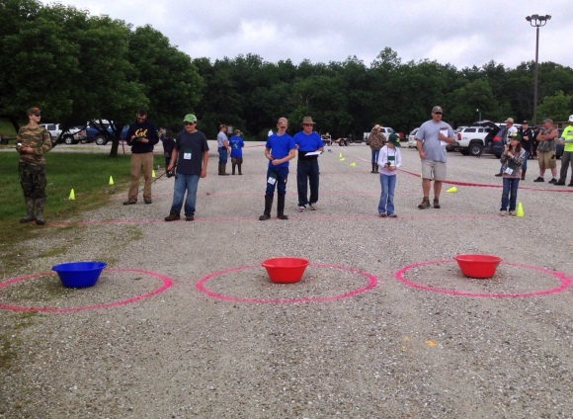
- Spin-casting, spinning or bait-casting equipment may be used, this will not be provided.
- Casts may be up to 60 feet distance.
- Multiple casts at 15, 30 and 45 feet were used in last year’s competition
- Targets may be of different diameters and distances.
- Casts scored for accuracy.
- Any casting method may be used.
- Must use a practice/rubber plug (one will be provided if youth does not have one).

Skill-a-thon
- This will include approximately 4-5 stations.
- Each station will give participant an opportunity to demonstrate their skill or knowledge of the 4-H Sportfishing project.
- See list of possible station knowledge and skills (on first page)
- Some possible knowledge/skill areas to prepare for; but not limited to these.
  - Worm Rigs – Texas rig, flippin’ rig, slider rig, jig head rig, split shot rig
  - Species of Fishes found in Missouri
  - 4-H Sportfishing Ethical Compass
  - Bobber fishing rig, bottom fishing rig, slip sinker rig, 3-way rig
  - Tackle identification
  - Fish parts
  - Aquatic Ecosystems
  - Knots and knots tying

Educational Demonstrations/Community Based Service Learning

This year youth, families, and have the opportunity to give back to the Missouri Department of Conservation. We will be doing a lake area clean-up while the final scores are being tallied. This is a family event! We will provide trash pick-up bags and gloves, thanks to the City of Columbia. We have held the statewide event at Little Dixie Lake Conservation area since we have held this event. We would like 4-H to give back. Don’t forget to tell your club how long you did your community service at this event for the club reports!!!

Questions: Contact Laura Browning, Assistant Ext. Professor (visiting), laurabrowning@missouri.edu, 573-882-8807

