Missouri State 4-H Kids & K-9 Camp

June 20-22, 2019

Camp Clover Point

Lake of the Ozarks, Missouri

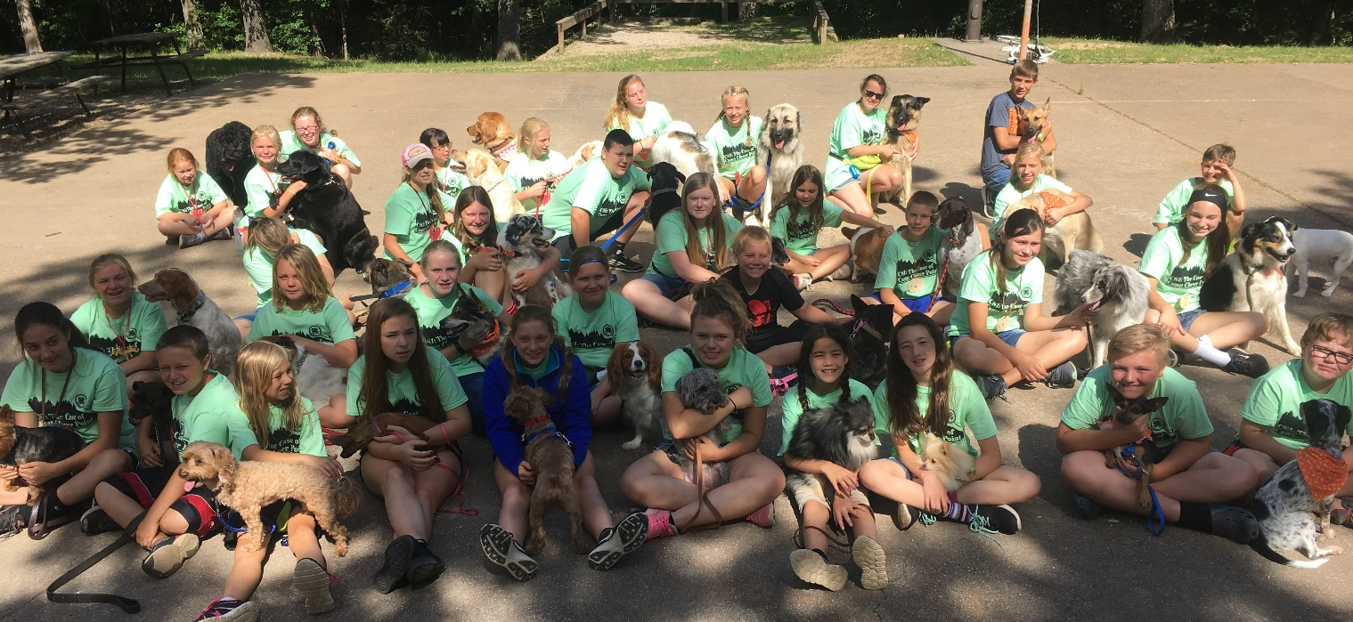

Join us for a pawsitively great time at the 2019 Missouri State 4-H Kids & K-9 Camp. A statewide 4-H camp for dog training, demos and fun. Come and learn training skills, meet new friends, and have fun with your dog!

Missouri State 4-H Kids & K-9 Camp

It’s all about the Dogs
Come join us for our fifth Missouri State 4-H Kids and K-9 Camp. A program designed to provide a canine training/themed experience for any 4-H youth looking for fun filled activities to do with their dog.

You can learn new training techniques, meet new people, get ready for the upcoming 4-H show season, and have fun with your dogs. We will introduce campers to activities and training seminars that will provide enrichment for the handler and their dog. Training is provided in agility, rally obedience and freestyle. Leashes needed for the sessions include a flat collar, training collar, obedience leash and 6-foot leather leash (NO retractable leashes)

It does not matter if you are a 1st year participant or an experienced 4-H’er in the dog program, we have activities for everyone. This weekend is run entirely by volunteers who donate their time. We are very fortunate to have the support of many canine fanciers, including 4-H alumni, parents, professionals in canine-related fields, and 4-H leaders, all helping to make this program possible.

Parents and youth, please read the information packet carefully, as many of your questions may be answered there. Additional information will be sent to those who register for the camp.

We look forward to seeing you in June.

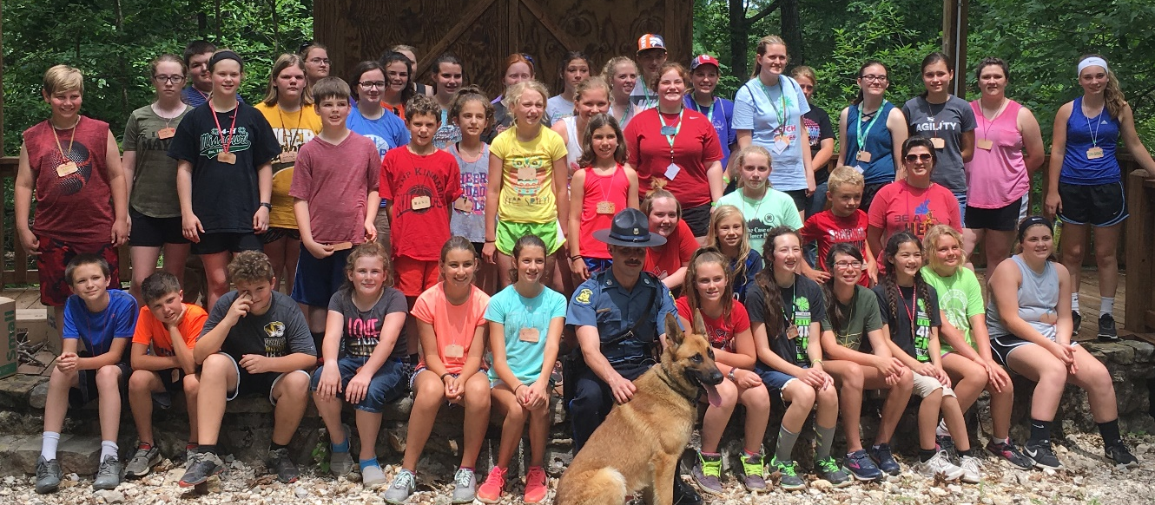
Sergeant Wallace and K-9 Rony, Missouri Sta te Highway Patrol
Who is Invited?
All 4-H Youth ages 8 - 18 (as of January 1st) and their dog are welcome.
(4-H leaders are welcome to attend and participate. All participants are responsible
for camp fees.)

How About the Dogs?
Dogs must be at least 12 weeks of age, in good health, free of contagious diseases and fleas. They must be well socialized to others (see Bandana Program) and will stay in the cabins with the campers overnight, resting in their crates. This is a forested area, so we highly recommend all dogs have flea and tick preventative on them.
If any dogs exhibit aggressive behavior, are dangerously out of control, or have any behavior that negatively impacts the experience or safety for others campers, directors have the right to remove the dog from the program. If you have concerns, feel free to discuss the situation with our director or your 4-H Dog Project leader.
ORANGE BANDANA PROGRAM
Dogs who need more space to feel comfortable will wear a special orange bandana, which we will provide. This does not mean they are bad dogs; they may just have a little more anxiety than others may. When a dog is wearing an orange bandana, give a little more room to this dog and speak to the handler to let them know you are passing. We will go over the best way to handle dog-dog introductions at the Rules and Safety Seminar. This is a top priority safety step for everyone. If you feel your dog might need this, be sure to mark the space on your application.
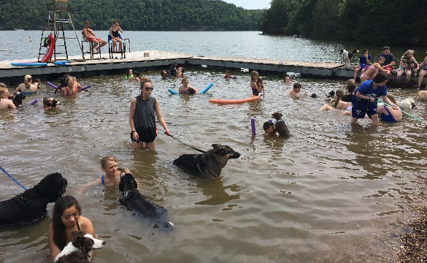

Missouri State 4-H Kids & K-9 Camp
Information and Camp Rules
Youth:
- All handlers must attend the Introductions and Camp Rules session the first day.
- Counselors are present in the cabin to assist youth and coordinate moving to sessions.
- Campers must be in control of their dogs at all times and will be responsible for clean- up, feeding and caring for their own dogs.
- The handlers must clean up all feces left by their dogs and deposit them in the cans provided.
- The Bubble Rule: Handler’s must keep their dog outside of any other dog’s personal space “bubble,” particularly so, if the dog is wearing an Orange Bandana (see page 3) which will indicate other dogs should keep distance.
- Buddy system: All campers must be accompanied by a fellow camper or counselor at all times. This includes moving from event to event, or exercising a dog at night.
- At all times, campers will behave in a manner fitting of 4-H. All campers will be respectful and kind towards all fellow campers, instructors, staff, and dogs. Poor sportsmanship, profanity, cheating, or interference with an instructor or judge’s decisions will not be tolerated.
- All campers must take part in their assigned activities.
- There will be no playing on or using equipment, i.e. Agility, Rally, etc. unless an Instructor/Advisor is present.
- Lights Out: All campers must stay in their cabins after lights out. If they must leave the cabin for any reason, i.e. for relief, walk dogs, etc. a buddy must accompany the camper, with a counselor’s permission.
- Parents are not allowed to remove a child from the campgrounds without checking in with the director.
- Absolutely no tobacco products, drugs or alcohol are permitted on the grounds.
- Cell Phones: Cell phones or other electronic devices (including smart watches, MP3 players, media players, etc.) are not allowed at camp. Please leave them at home. We prefer no electronic devise but if a youth brings, they will be collected for the week.
- Cabins are not air-conditioned.
Dogs:
- Dogs must be at least 12 weeks of age, in good health, protected against fleas and ticks and had all applicable vaccinations for their age including: rabies, DHLPP, Bordatello and rabies. Proof of vaccinations must accompany application. The committee recommends all dogs be microchipped for safety.
- Dogs must be on leash at all times unless briefly required by the individual sport, such as agility. When resting, at night, and during meals dogs must be crated. Be sure to bring a towel, or sheet to cover the crates of noisy dogs.
- Food and treats must be stored in airtight containers until ready for use.
- Dogs will not be allowed in the dining hall. Dogs will rest in their crates during meal times.
- The Bubble Rule: Handler’s must keep their dog outside of any other dog’s personal space “bubble,” particularly so, if the dog is wearing an Orange Bandana (see page 3) which will indicate other dogs should keep distance.
- No aggressive or highly reactive dogs will be allowed at camp. Dogs that exhibit aggression may be asked to leave the premises. Dogs requiring more personal space from other dogs will be asked to wear an Orange Bandana as a precaution during activities. It is the handler’s responsibility to assure their dog has sufficient space to feel comfortable. If an orange bandana will be needed, please mark this on the application.
- No dogs in heat will be allowed to attend. If a bitch comes into season during the event, that dog will be removed from further attendance in groups and may be asked to leave.
- Upon check-in, please share any special needs your dog may require.

Note: Information and additional rules may be added as necessary.

Transportation

All campers, parents and volunteers are responsible for transportation to and from
Camp Clover Point.

Packing List: Please clearly label all items with the camper’s name.

For the Dogs: (all equipment must be clean and in good repair)
Vaccination/ State Health Certificate
Portable Kennel Crate
Crate Blanket / Bedding
Crate Cover or Old Sheet (to help dogs rest undistracted) – if required
Food, Water and Chew Toy for your dog (food must be in airtight container)
Food and Water Dishes
Collars and Leashes (see page 2)
Treats and Training Toys, such as Tug Toys or Ropes
Plastic Clean-Up Bags – at least 10-12
Old Towels – 2 to 3 – for cleaning up, wetting to cool down, or to dry off dogs
Fan or Crate Fan (optional, but recommended)

For Campers:
Pillow/Pillow Case
Sleeping Bag, or 2 sheets and blanket
2 Pair Shorts
1 Pair Jeans
3 Pairs Socks
3 Changes of Underwear
3 Short Sleeve Tops
Sleeping Clothes
Running Shoes for Agility and Other Training
Alarm Clock
Flashlight
Towels
Toiletries (toothbrush, toothpaste, soap, shampoo, deodorant, etc.)
Water Bottle
Sunscreen
Insect Repellant
Sunglasses
Rain Gear, Jacket, Umbrella, if the forecast calls for rain
Swimsuit & Beach Towel
Flip Flops for shower-not allowed outside
Closed toe shoes
Fan – may want one for you and one for your dog
Short extension cord

