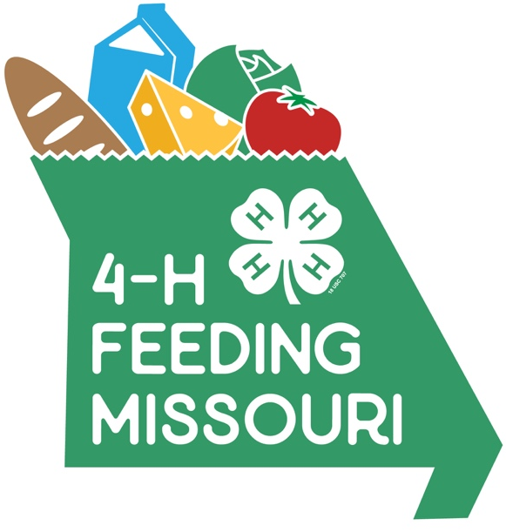
Coming
soon!

4-H Feeding Missouri
Statewide Food Drive
February 1-28, 2019

Get involved! Help fight hunger across Missouri!
1 million meals!
That’s our goal!
From February 1-28, 4-Hers across Missouri will partner with Feeding Missouri in a friendly service competition.

Help organize and/or participate in:
- Food drives
- Fundraising
- Volunteering at local food banks and pantries
- Outreach to educate communities about hunger and food insecurity
Learn more at 4h.missouri.edu
or contact (Club name) at (phone) or (email)

