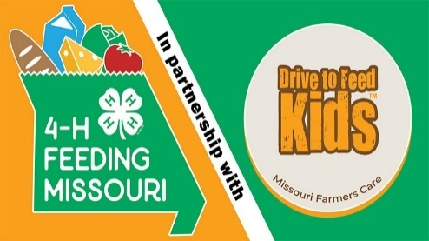
4-H Feeding Missouri/Drive to Feed Kids Mini-Grant Final Report
County:
Name of Group Awarded Grant:
Name of Contact Person:
Contact Person Email:
County 4-H Youth Specialist or Youth Program Associate Name:
Number of Youth who Participated with the Project:
Number of Adults who Participated with the Project:

Total Number of Hours Worked on the Project:

Please list Expenses occurred, Gifts-in-kind, Community donations:

Provide a brief description of your project/event.

Provide a description of how you educated others about food insecurity.

Please attached photos, news clippings, etc.

Please email to Maria Calvert, calvertml@missouri.edu or mail to Maria Calvert 1110 S. College Ave. Columbia, MO. 65211. Final reports are due by May 31st.

