University of Missouri Extension 4-H Program
County 4-H Council Volunteer Role Description

Name of County:_____________________________________________________________________________
Name of Club/Group: _____________________________________________________________________
Purpose: Represent club or group at county-level 4-H council meetings to ensure the local 4-H program consistently:
- Supports the positive growth and development of all youth involved
- Creates intentional opportunities for all youth to learn, lead and serve
- Promotes life skill development in all youth
- Engages all youth so they become competent, caring and connected citizens of character in their community.
Time required: 2-5 hours each month, 12 month role.
Qualifications:
- Must complete the Missouri 4-H volunteer application and screening process and be
- accepted as a volunteer.
- A willingness to become familiar with and work within the philosophy and guidelines of the University of Missouri State and County 4-H Program.
- The ability to organize information and make decisions.
- The ability to work and communicate effectively in both verbal and written forms.
- The ability to motivate parents and others to serve in recognized volunteer leader roles.
- A sincere interest in working with youth, other volunteers and professional staff in an educational
setting.
Responsibilities:
- Follow all 4-H guidelines and policies of the Missouri 4-H program.
- Be committed to young people and their growth in all areas.
- Promote favorable public relations and image for 4-H program.
- Help analyze the needs and interests of county youth and volunteers.
- Inform professional Extension staff concerning training needs of members or volunteers, resources
needed to solve specific problems and/or concerns, and any other information as deemed important.
- Assist with planning, conducting, evaluating, and recommending educational experiences, methods,
and programs that will meet the needs and interests of youth.
- Attend all committee meetings.
- Secure material resources as needed to conduct, promote, and expand the 4-H program.
- Be dedicated to young people and sensitive to their abilities and needs.
- Encourage 4-H members' and parents' interest and participation.
- Welcome parents' ideas, assistance, cooperation, support, and attendance at 4-H activities.
- Read 4-H newsletters and literature from the county Extension office.

Benefits:
- Experience the satisfaction of contributing to the positive growth of youth
- Grow personal leadership and communication skills
- Gain respect and gratitude of members, volunteers, parents, and the community
- Recognition for your contributions
Boundaries and Parameters:
- [Describe the parameters or boundaries the person must stay within as they work to fulfill the responsibilities. What policy, procedures, quicksand, etc does the person need to know before staring any tasks?]
Missouri 4-H staff agree to:
- Provide training opportunities that will help the volunteer fulfill his/her responsibilities as a 4-H
Council member
- Provide appropriate manuals, pamphlets, audio-visual aids, newsletters and other resource materials
- Have professionals available to listen to volunteers' ideas to help improve the 4-H program
- Provide appropriate recognition and awards to volunteers

Contacts:
County 4-H Council Member

Name: ____________________________________________ Club______________________
Address: __________________________________________ Phone: ____________________
Email: _____________________________________________

Volunteer Supervisor/University of Missouri Extension Youth Staff

Name: ____________________________________________ Club______________________
Address: __________________________________________ Phone: ____________________
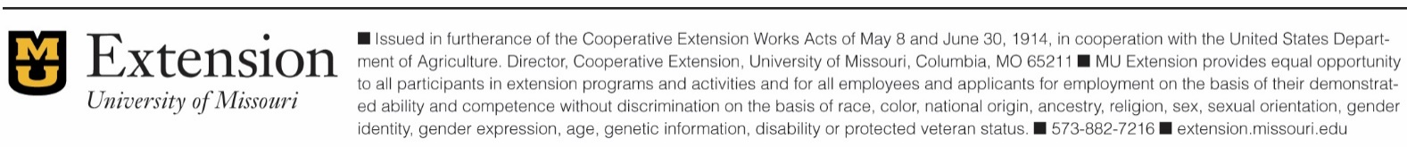
Email: _____________________________________________

