QuickBooks Credit Card Merchant Service
July 26, 2010

What is the Merchant Service?
The Merchant Service allows you to process credit card transactions within QuickBooks. After the council’s application has been approved by Intuit, these instructions will assist you in setting up the Merchant Account in QuickBooks and using the credit card process.

A Merchant account number will be assigned to your office. This number will be required when requesting Merchant Service support from Intuit. The 16-digit merchant account number is located in several places:
- On the top right of every screen in the Merchant Service Center.
- At the top left of your merchant account statement.
- In your application approval email.
- Within Merchant Service Center setting (select Account, Settings & Alerts).

The Intuit QuickBooks Merchant Service Application
The first step is to complete and submit an application. The information that will be required:
- Business Information (mailing address, establishment date)
- Contact information (Principal/owner, name, address) - Extension council as owners; CPD’s name is recommended for contact name.
- Basic council financial information (bank account number, estimated sales figures)
Remember that the Extension Council is the legal authority. When an email address is requested, use the email address for the extension office.

- Call 877 214 3641 and tell the Intuit credit card person that you are working with the national Accounts credit card program and Keith Greener (he is our Intuit representative) and you want the National Accounts Credit card Rates program applied to your account.

- For the Login name, use the county’s email address.
- For the password, use extension.
- For security questions, if possible, use the same questions and answers applied during the QuickBooks software installation.
What is your first pet’s name? toby
City where you went go to high school? granite
Note: If the above questions and answers were not available, please advise the QuickBooks Administrator of the new set of questions and answers.

After submitting the application, your office will receive an email message from Intuit Innnovative Merchant Solutions, indicating that they have received your application and are reviewing the application. To complete the application review, the following information must be submitted by email or fax to Innovative Merchant Solutions.
- A copy of the IRS confirmation letter to support your non-profit/tax exempt status. Go to http://extension.missouri.edu/staff/adminmgmt/fiscal/irs_%20letter.pdf to save the file.
- Copies of the council’s last 3 month’s business bank statements. Scan and save each statement to a file for attachment or copy and fax.
- Attach or fax the above documents to Innovative Merchant Solutions, as instructed in their letter.

If your office does not receive an approval notification from Intuit Innovative Merchant Solutions within one week, call the QuickBooks Merchant Services at 800 558-9558.
It is a good idea to scrutinzie the credit card transaction fees charged to your Merchant account every month to verify that the special rates were applied.

Special Pricing for University of Missouri Extension
Set up fees | $0
Monthly fees | $14.95  waived for 2 mos.
Online Internet Credit Card Business –class or workshop; publication sales | $9.95 per month
Keyed rate  Non- Qualified rate (NQ)  (corporate, commercial, purchase cards) | 2.20%  3.54%
Swipe Rate | 1.64%
Per txn fee (Q/MQ)  Per txn fee (NQ) | .27¢ *  .34
Monthly minimum | $20  Waived for 2 mos.
Cancellation Fees | $0
USB Card Swiper | $89.00
Billing Solutions ** Email Invoices | $14.95 per month
*Per Transaction fee also applies to chargeback or customer credit transactions.
** Note: QB Invoices can be sent without utilizing Billing Solutions.
Payment Solutions
- Retail – onsite/office
- Mail-order/Telephone order
- Recurring customer credit card sales
- Virtual Terminal – Accept credit card sales at conference or Fair site offline or online. Offline purchases can be processed via credit card security later at office.
- Reconcilation Tools – view credit card amounts ready for deposit. Download fees to QuickBooks.
- Internet Business (web store) – online credit card sales for publications, conference/workshop registration. $9.95 extra per month.
- USB Card Reader connect to computer for swiping credit cards – approximately $89.00 per device.

- Two QuickBooks data files – If you have two QuickBooks Data you can use one Merchant Account if:
- You use only one Federal Tax ID for both accounts
- You must use the same bank account for each data file.
- Is Annual Fee payment Possible? – Intuit can only process the $14.95 fee monthly

QuickBooks Adminstrator Password
Due to Security regulations for credit card processing, QuickBooks will require that the Quickbooks Administrator password be changed every 90 days. The Administrator login is required when changes are made to the office’s QuickBooks Merchant Service credit card account.
When the Quickbooks Administrator login is requested or requires a password change, call or email one of the two following university personnel: Mary Ann Horvath 314 516-6153 or Shelly DeJaynes 573 882-4622.

Issues
- Your Merchant Deposit report shows credit card transactions deposited (funded) but the amounts may not appear in the council’s bank account until 24 hours later.
- Internet Explorer version 8 must be installed. There may be a possible Active X problem. Software adjustments may be necessary. Intuit Merchant cusomter service support help will provide assistance. 800-558-9558.
- Avoid special credit card features which will charge extra fees: Authorization and Capture, Billing Solutions, etc.

QuickBooks Preferences
Several preferences require adjustments and will require that the QuickBooks Administrator log in.
- Select Edit from menu bar.
- Select Preferences.
- On the left side bar, select Payment.
- Under Company Preferences tab, turn on Credit card processing.
- Under the section, “Receive Payments,” place preceding Use Undeposited Funds as a Default Deposit to Account.
- On the left side bar, select Sales & Cusomters.
- Under My Preferences and under Add Available Time/Costs to Invoices, select Don’t Add Any.
- On the left side bar, select Desktop view.
- Under Company Preferences, if you want to see Invoices, Sales Receipts and Statement and Statement Charges on your Home Page, select one or more of these features. OPTIONAL.
- Click OK to save preference changes.

Create a Credit Card Transaction Fee Expense Account.
- Select Lists from the menu bar.
- Select Chart of Accounts.
- At the bottom left corner of screen, select the Account button. Select New.
- Select Expense and then click Continue.
- In the Number field, enter a 7xxx number.
- Enter an Account Name.
- Place a precding Subaccount of, if you want to make this account a subaccount under 7000. OPTIONAL.
- Click Save and Close.

What you should know before processing a credit card payment online (Merchant Service)
Before processing a credit card payment through QuickBooks Merchant Service, it is important to understand the following information.

What types of credit cards can I accept with Intuit QuickBooks Merchant Service?
Visa, MasterCard, American Express, Discover Network, and JCB.
What are Commercial Cards, and how do I process them?
Commercial cards are credit cards issued for business use, like corporate cards, purchase cards, or travel and entertainment cards. Both Visa and MasterCard offer special credit cards for companies designed to help manage spending and streamline the purchasing process. Accept and process commercial cards as you would any credit card. Higher merchant rates (non-qualified rate) usually apply to purchases on commercial cards.
Key-entered Transactions
For a key-entered transaction, the credit card does not need to be physically present to authorize the transaction, as it does if you use a card reader. Instead, the information is processed over the Internet (as with the Merchant Service for QuickBooks), by e-mail, over the phone, or by similar means. All you need is the customer name, the customer's address, the card number, and the expiration date.
This processing method gives you more flexibility (for example, you can accept credit card payments over the phone) and enables you to download your payment transactions directly into QuickBooks. However, using this method also means that you, as the user of the merchant account, have full responsibility for safeguarding against fraudulent transactions. To help reduce the amount of fraud, the Merchant Service for QuickBooks performs an address verification check for each credit card transaction by comparing the customer address you enter with the credit card bank records.
Credit Card numbers should not be filed or saved.

Card-swiped transactions
For a "card swiped" transaction, the merchant swipes the credit card through a terminal or other device that reads the card's magnetic stripe. Card-swiped transactions qualify for a lower discount rate because they carry a lower risk of credit card fraud. If you do repeat business with a customer, you must swipe the credit card every time you process it to receive this lower rate for each transaction.
Whenever you are unable to swipe the card (for example, if the card's magnetic stripe is damaged), it's a good idea to imprint the card and complete a sales slip. Imprinting the card proves that the card was physically present if a customer later disputes a charge.

Address Verification Service (AVS) for credit card security (Merchant Service)
Whenever you process a key-entered credit card transaction, QuickBooks verifies the cardholder's address by comparing the address you enter with the customer's credit card bank records.
This check is carried out using the Address Verification Service (AVS). Address verification helps merchants avoid credit card fraud and chargebacks for transactions in which the credit card is not physically present at the point of sale.

ZIP code and Street address
Only ZIP code is required to complete the address verification check, but you can include street address for extra protection against fraud and chargebacks. For example, if a customer denies having made a particular credit card purchase, showing the credit card company that you collected the customer's street address may help prove that the charge was legitimate.

What is a credit card chargeback?
A chargeback is a credit card payment transaction that a customer later disputes. The transaction is being "charged back" to you after the original credit card payment transaction was authorized by the merchant account processor and deposited into your bank account.
This type of transaction can occur for a variety of reasons. For example, this might happen if a customer denies having made a particular credit card transaction and refuses to pay the credit card company. You must research the individual transaction to determine whether or not the chargeback is appropriate.
You have the right to challenge by filing a rebuttal. The Chargeback fee is $20.00 and is a processing fee not a penalty fee. The original credit card sales amount also will be charged back to your Merchant account.
Two Ways to Enter QuickBooks Credit Card Transactions
QuickBooks Merchant Service credit card transactions may be entered in one of two ways:
- Method 1 - Online using the Virtual Terminal Plus - This feature is useful if you want others in your company to be able to process credit cards without having access to QuickBooks. You can log in to Virtual Terminal Plus from a computer running QuickBooks or from a different PC.
Bookkeeper creates invoices to match Virtual Terminal credit card transactions.
- Method 2 - Within QuickBooks – Create a Sales Receipt to process and submit credit card transactions.

Getting Started with Virtual Terminal Plus
Logging In
Each time you use Virtual Terminal Plus, you must log in using your QuickBooks Business Services login information.
To access Virtual Terminal Plus, go to:
http://merchantaccount.quickbooks.com/virtualterminalplus/ and select Login In button.
Log in with your QuickBooks Business Services login. (If you do not have a login account, under the login screen, select click here to create a login name and password. It is recommended that you use the county’s email address as the login name and for password extension.
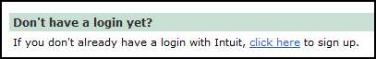
To protect your QuickBooks Merchant Service from unauthorized access, safeguard your login information and log out whenever you are not using Virtual Terminal Plus.
Uploading Your QuickBooks Customer List
When you process a payment using Virtual Terminal Plus, you can select the customer you are receiving the payment from, just as you do in QuickBooks. By selecting a customer, QuickBooks can automatically apply the payment to any outstanding invoices for that customer when you later download the payment to QuickBooks.
To use this feature, you must first upload your QuickBooks customer list to Virtual Terminal Plus:
- Log out of Virtual Terminal Plus.
- Follow the steps for downloading Virtual Terminal Plus payments to QuickBooks (see section, Download Merchant Service Payments to QuickBooks). Bookkeeper or CPD.
Whenever you download payments, QuickBooks automatically synchronizes your Virtual Terminal Plus customer list with your QuickBooks Customer:Job list.
Note: Uploading your customer list the first time can take several minutes if you have a large number of customers.
- Return to Virtual Terminal Plus and log in.
The Select customer list should display all your customers.
Processing Transactions
You can use Virtual Terminal Plus to process both payments and credits. When you process a payment, you can choose to save a record of the transaction for downloading to QuickBooks.
To set up a transaction:
  - Log in to Virtual Terminal Plus.
  - On the Set up payment page, choose either the Sale or Credit tab.
  - Follow the onscreen instructions to process your transaction.
  - You can either key-enter or swipe a customer's credit card.
  - If you key-enter, credit card information or address information is required to perform an AVS check. Be sure to enter the credit card user’s name correctly as it appeaers on the credit card. Be careful with initial and periods!
  - Once the transaction has been approved, you can print a receipt for your customer and for your records.

- Sample screen shots.
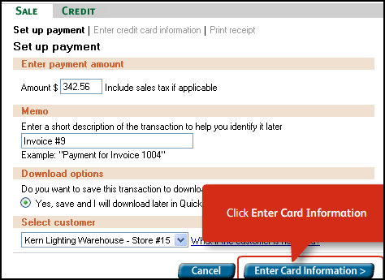
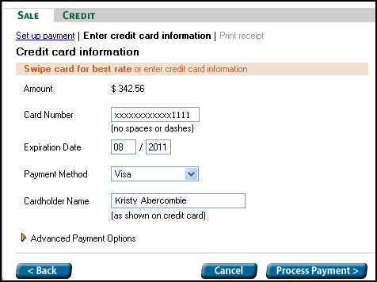
Printing Receipts
  - When you process a transaction using Virtual Terminal Plus, you receive prompt notification on the screen as soon as the payment or credit is approved.
  - From this screen, you can print copies of the transaction receipt.
  - Print two copies of the receipt. If customer is present, have your customer sign the "Merchant Copy" and give your customer the "Customer Copy."
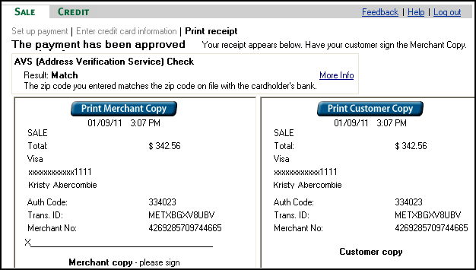

Write on the Merchant copy document a description of the sale (soil testing, program name, etc) and place the document in a folder for later processing by the Bookkeeper.

Void or Reverse Transactions
In Virtual Terminal Plus, voiding is available immediately after processing on the screen that notifies you of the payment approval. If you need to void a transaction after the notification screen has closed, use Merchant Account Service Manager:
From the QuickBooks Customers menu, choose Credit Card Processing Activities and then Merchant Service Center.
Note: You can void a credit card payment on the day you process the transaction. After that time, the transaction has been settled and cannot be voided. To reverse a credit card payment after the settlement period, you must issue the customer a credit instead.
*************************************************************

The Remaining information is for the Bookkeeper and County Program Director

Create Sales Items
Before creating a Sales Receipts transaction, appropriate sales items are required. A Sales Item must be created and linked to an existing income account (or expense account, if reduction of expense). Here is a sample list of Sales Items.
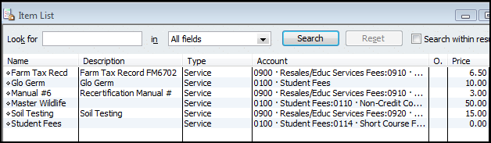

- Open the Item List. Lists from the menu bar, Item List.
- Select the Item button at bottom left of screen.
- Left click on New.
- Click the down arrow for Type and select Service. (for most Extension-related activities)
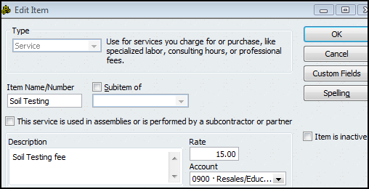
- Type an Item Name
- The Description box is optional.
- Enter a rate, if the rate is fixed. Otherwise, leave the rate field blank.
- Under Account, select appropriate Income Account, or Expense account if amount received is a reduction of expense. An Account is Required!
- Click OK.

Issues:
- An Item must be created for each income type. (see above section, “Create Sales Item”)
- Each Item must be related to an existing Income account.
- A customer invoice must be created with an appropriate sales item identified.
- Customer Payments are download and recorded in the asset account, 1499-Undeposited Funds, and is held in this account until the credit card amount has been deposited in the bank account.
- When credit card transactions have been deposited in the council bank account, move the amounts from the Undeposited Funds to the Deposit Screen.
- Customer Invoice and Sales Receipt Transactions appear in the Register and Funds Class Balance. (see section, “Configuring Reports for Accurals.”)
Credit card transactdions are downloaded as customer Payments and matched to the customer invoice
Record Received Payment in Deposit Screen
Create an Invoice or Sales Receipt
Create a Sales Item

Method 1 – Virtual Terminal
Enter credit card transactions on the Virtual Terminal Plus web site. Bookkeeper creates invoices to match credit card amount to downloaded Virtual Terminal transactions.

Create a Customer Invoice
To record and accrue the customer income, create a Customer invoice. Data must be entered in the QB customer invoice in order to record the accrued income in the council accounting records and establish it as an Accounts Receivable.
- Select Customer from the menu bar.
- Create Invoices
- Click the down arrow for Customer:Job and select the appropriate Customer name. The customer’s address will appear in the “Bill To” box (if the customer address previously was entered in the Customer List). Or, select “Add New” to create a new Customer.
The customer name in QuickBooks must match the customer name entered for the Virtual Terminal credit card transaction.
- Enter a Class Code (very important!)
- The UOE Service Template should already be selected.
- Enter invoice Date.
- Invoice and P.O. # fields are optional.
- Under Item, select the appropriate Sales Item . Or, select “Add New” to create a new Item.
(see section, “Create Sales Item.”)
- Enter a Description
- Enter a Rate, if appropriate. Or, the rate will display if it was identified in the Item setup.
- Enter Quantity, if appropriate.
- Class code will be displayed in this row as it appears at the top of the screen.
- Enter Amount.
Note: multiple sales transaction items may be entered on an Invoice.
- Enter a Customer Message, if appropriate. Customer messages may be stored for future use.
- Click Save and Close, or Save and New.
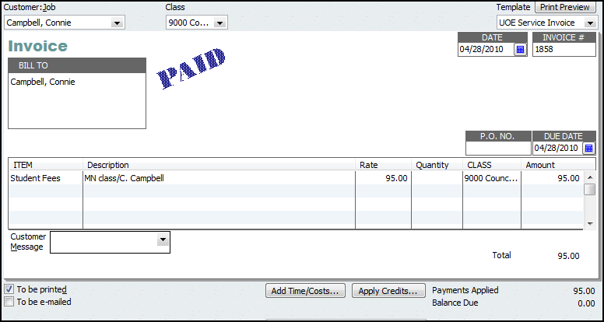
Download Merchant Service Payments to QuickBooks
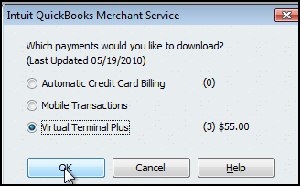
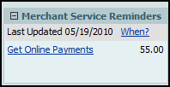
When you process transactions using Virtual Terminal Plus, your books will not be up-to-date until you record the transactions in QuickBooks. To simplify this task, you can download a list of all the payments processed using Virtual Terminal Plus in QuickBooks. (Currently, it's not possible to download a list of credits processed.) If you process credits using Virtual Terminal Plus, you need to remember to record them in QuickBooks.
To download and record payments
- To download payments, you may either:
  - Click on the message in your reminder list, or
  - Choose Receive Payments from the Customers Menu, and then click Get Online Pmts on the toolbar. In the Get Online Pmts window, choose Virtual Terminal Plus payments and click OK.
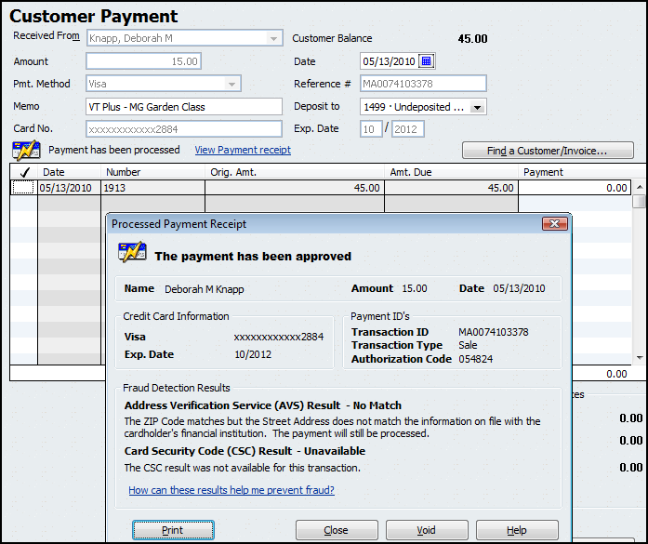
Match Downloaded Payments to Invoices
QuickBooks connects to Virtual Terminal Plus and displays a list of all the payments processed since your last download. At the same time, QuickBooks applies the payments to any outstanding invoices for those customers. If an customer invoice does not exist in Quickbooks, create the invoice and match it to the downloaded customer payment transaction from the Merchant Service.
Note: Whenever you download payments, QuickBooks automatically synchronizes your Virtual Terminal Plus customer list with your QuickBooks Customer:Job list.
If the Invoice amount and downloaded customer payment do not match, then correct the invoice amount. Then match the correct amount in the customer payment screen.
How does QuickBooks apply payments to invoices?
By default, QuickBooks is set to automatically apply payments for you.
Where to find this preference (The QuickBooks Administrator is needed) Optional
From the QuickBooks Edit menu, choose Preferences, and then select the Sales & Customers icon. Click the Company Preferences tab. When Automatically apply payments is on, QuickBooks applies payments to the outstanding invoices for that customer. If the amount received is less than the customer's outstanding balance, QuickBooks applies the payment to the oldest invoices first. This is OPTIONAL.

Move Payment Amount to Deposit Transaction
When the credit card transactions less fees are deposited in the Council’s bank account (bank statement), the Payment amounts are moved from the Payments to Deposits screen to the Deposit screen.
- Select Bank from menu bar.
- Select Make Deposits.

The following Payments to Deposit screen will display, if there are undeposited customer amounts.
If the screen does not display, select in the Deposits Screen.
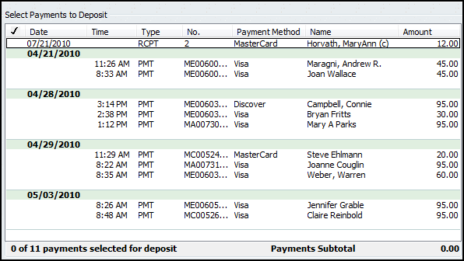
Insert a in the checkmark column for the Sales Receipt payment that was deposited in the council’s bank account.
Click OK. The Sales Receipt data will display in the Make Deposit screen.

In the Deposit Screen
- Appropriate credit card data are included in the deposit screen.
- The Account field is protected. You will not be able to change the account number.
QB records all Invoice or sales receipt data temporarily in an account named, 1499-Undeposited Funds. The amount is offset in the Undeposited Funds when the amount is recorded and saved in the Deposits screen. The original invoice or sales receipt transaction included the income (or expense) account.
- Multiple credit card deposits, reported on the bank statement, may be recorded in the same deposit screen.
- Do not mix Cash and Check payment method types with Credit Card type. A Deposit slip cannot be printed for credit card payment methods.
- Select the Print button at the top of deposit screen to print a Deposit Summary report.
- Click Save and Close, or Save and New
- Deposit Summary report should be compared to the monthly bank statement.
- When matched, the credit card receipt should be marked as deposited and transferred to another file folder, marked as “completed credit card transactions.”

Sample Deposit Transaction

Configuring Reports for Accurals
Since Accounts Receivables or Undeposited Funds are considered accured income, these Invoice or Sales Receipt transactions are recorded in the month in which the transaction occurred. However, customer payment may be received in the following month.
When configuring a report that captures accured transactions (Accounts Receivables or Payables) i.e. Ledger, Accounts Receivable, or Monthly Income and Expense Summary reports, the following adjustments should be made to capture the original Invoice (or Bill ) transaction.

Under the Modify Report button, Display tab
Report Basis = Accural
Under the Filters tab,
Transaction types also should include Invoice, Payment (Bill, Bill Payment for Payables)
Accounts filter also should include Accounts Receivable (Accounts Payable for accrued expenses).

When configuring any report that captures the actual receipt of customer money ( or actual check written to a vendor to pay a bill) i.e. Funds Class Balance Report, the following adjustments should be made to capture the deposit for the Invoice transaction.

Under the Modify Report button, Display tab
Report Basis = Cash
Under the Filters button,
Transaction types also should include Invoice, Payment (Bill, Bill Payment for Payables)
Accounts filter – Accounts Receivables (Payables) should NOT be checked).
The exclusion of the Accounts Receivable (Accounts Payable) from the Accounts filter does not alter the Funds Class Balance Report. However, it does eliminate the incorrect display of the negative sign for positive class balances.

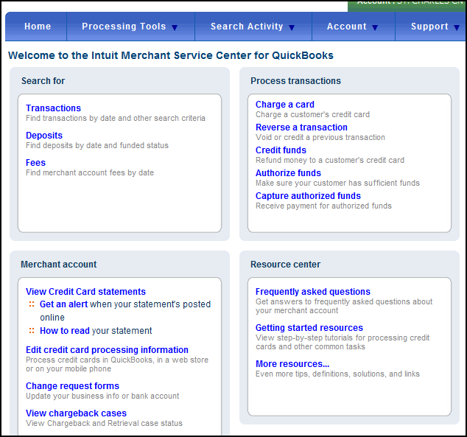
Information, Tutorials and Reports from the Merchant Service Center

In your Merchant Service account, you have access to lists or reports for funded and unfunded transactions, fees, and other features.
Under the Resource Center, there are excellent tutorials for your review. This is a good place to start. There are many details for Merchant Service credit card processing. These resources also can be used as a reference tool.
- From the Customers menu, choose Credit Card Processing Activities and then Merchant Service Center.
- Use the report options and filters to create a report that meets your needs.

Merchant Service Transactions Report
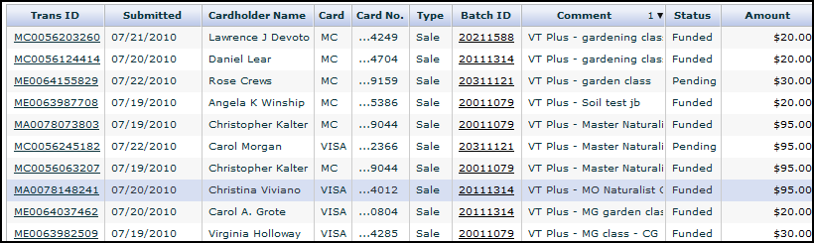
An Advanced Search feature allows you to find a specific credit card transaction, using multiple search criteria.

Other Merchant Service Reports include:
- A Deposits Reports of all funded (deposited) transactions that were tranferred to the bank account.
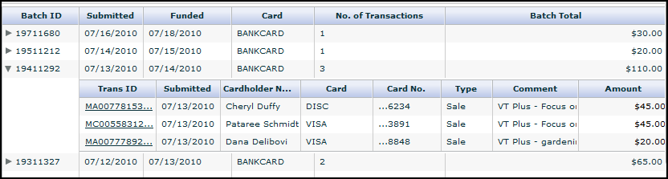

- Transaction Fees Report
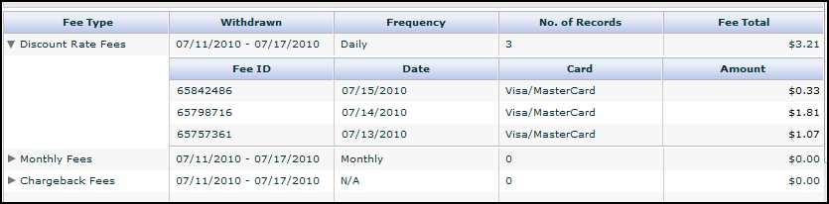

- Credit Card Monthy Statement includes a summary of daily deposits and fees.
(No illustration provided)

QuickBooks Reports
Here are two sample reports that will assist in tracking credit card transactions. Report configurations follow the two illustrations.

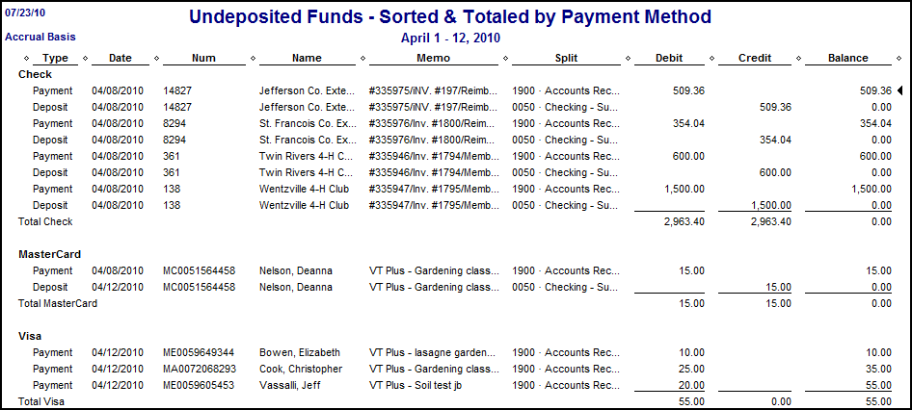
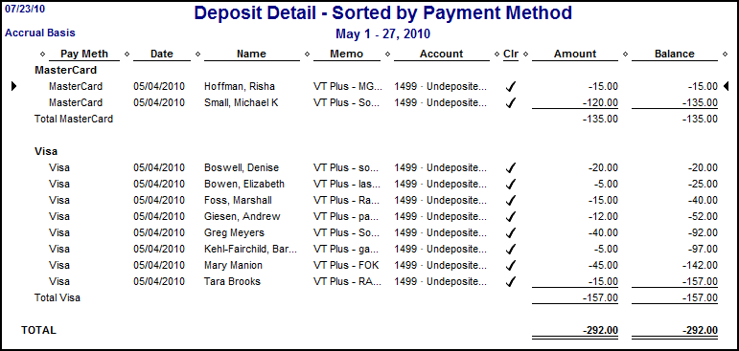
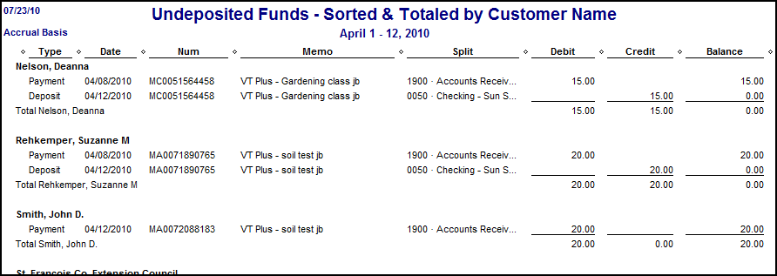

Configure the Undeposited Funds Report
- Select Report from menu bar.
- Select Customer Transaction Detail report.
- Select Modify Report button.
- Select the Filter tab.
- Under Choose Filter, select Accounts.
- Move cursor to the right and under Account, click down arrow and select 1499-Undeposited Funds account.
- Select the Header/footer tab and under Report Title, change the title to Undeposited Funds Report, or another title.
- Click OK.
- Remove the columns: Clr and Account from the report. Optional.
- At the top middle of report (under the Refresh button), click the down arrow for Total By and select Customer. (or Payment Method)
- To the right of Total By, select the down arrow for Sort By and select Date. ( or Name)
- Select appropriate Date Range.
- Select Memorize button and save report in the Memorized Report List.

The Undeposited Funds outstanding balance and Accounts Receivable outstanding balance will appear in the Balance Sheet report.

Configure the Deposit Detail Sorted by Payment Method
- Select Report from menu bar.
- Select Customer Transaction Detail report.
- Select Modify Report button.
- Select the Filter tab.
- Under Choose Filter, select Accounts.
- Move cursor to the right and under Account, click down arrow and select Multiple Accounts.
- Select all income and expense account (Select 1499-Undeposited Funds if you are using the Accrual Posting Method)
- Return to Choose Filter and select Transaction type.
- To the right, under Transaction Types, select the down arrow and select Deposit.
- Select the Header/footer tab and under Report Title, change the title to Deposit Detail – Sorted by Payment Method, or another title.
- Select the Display tab, and under Columns select Pay Meth.
- Under Columns, uncheck Type, Num, and Split.
- Click OK.
- In the report, you can move the Pay Meth column to the far left, if you wish.
- At the top middle of report (under the Refresh button), click the down arrow for Total By and select Payment Method.
- To the right of Total By, select the down arrow for Sort By and select Name.
- Select appropriate Date Range.
- Select Memorize button and save report in the Memorized Report List.
Under the Payment Method filter, you can select only the credit card method types and exclude cash and check.

Note: When the 1499-Undeposited Funds account is included in this report, QuickBooks will reverse all positive and negative amounts.

Method 2 - Create Sales Receipt in QuickBooks
Customer credit card transactions may be entered and submitted to the QuickBooks Merchant Service by the Bookkeeper within QuickBooks from the Sales Receipts Screen.

- Select Customer from the menu bar.
- Select Enter Sales Receipts.
- Select customer name, or select Add New to create a new Customer.
(Do not use a vendor name when identifying a person in the Sales Receipt screen.)
- Enter class code.
- Enter date.
- Sale No field is optional.
- Select appropriate credit card type Payment Method
- Select appropriate Item Name, or select Add new to create a new sales item.
- Enter a description, quantity, and rate, when appropriate.
- Select a class code in the second class field.
- Enter an amount.
- Enter information in the Memo text box.
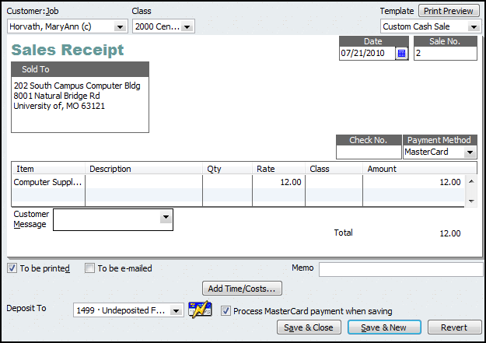
- For the Deposit To field, select 1499-Undeposited Funds. The Undeposited Funds is a temporary holding account and is represented in the Chart of Accounts and Balance Sheet report.
- Select Process Credit Card payment when saving.
- Click Save and Close. The Intuit Credit Card information screen opens.

- Complete the credit card information.
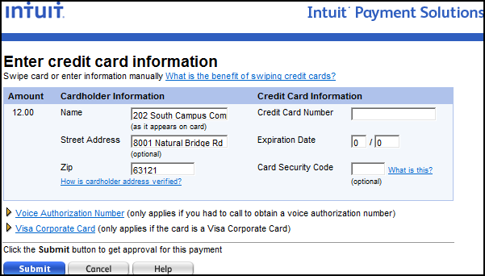
- Click Submit when ready to send credit card data.

Print Sales Receipt and attach to Merchant Service Credit Card receipt and file in appropriate folder. A copy of the Sales Receipt or the Merchant Service Credit Card receipt may be given to the customer.

Follow above procedures for downloading customer payments from Merchant Service to QuickBooks and for generating reports.

