Laclede County
Youth in Agriculture Awards
2025

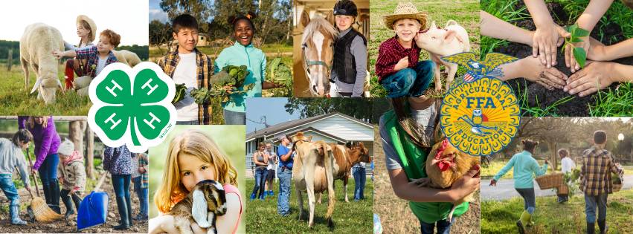
Brought to you by




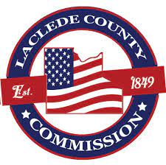

Laclede County
Youth in Agriculture Awards 2025

About the Award
In partnership with the Laclede County Commission, the Laclede County Council of the University of Missouri Extension presents the "Laclede County Youth in Agriculture Award 2025." All Laclede County youth ages 12 through 18 participating in Missouri 4-H and FFA are eligible for this annual award. The recognition highlights the importance of engaging young people in agricultural activities and to the potential benefits of the farming industry and rural communities in general within Laclede County. Our youth are the architects of Laclede County’s future. Their involvement can help sustain and advance the agricultural sector, impacting food security and innovation in farming practices.

The Laclede County Youth in Agriculture Award includes two, individual monetary awards in the amount of $250 each, to assist Laclede County youth in funding projects, research, and scholarly endeavors, as well as a beacon of hope for the future of agriculture. The Award is designed as a call to inspire and empower young individuals to take on leadership roles and pursue entrepreneurial endeavors in the agricultural sector, promising a brighter future for all members of our beloved community.

About Missouri 4-H: As America’s largest youth development organization, 4-H offers youth, families, and adult volunteers of all ages many ways to engage, grow and serve — through clubs, camps, contests, conferences, special interest groups, in-school and afterschool programs, and more. It’s about young people making new friends and memories while preparing to be future leaders — from both rural and urban areas.

About FFA: The National FFA Organization, often referred to simply as FFA, is an American non-profit career and technical student organization, which offers middle and high school classes that promote and support agricultural education.

LACLEDE COUNTY YOUTH IN AGRICULTURE AWARD 2024

Application Guidelines

- Applicants must participate as an active member of Laclede County 4-H and reside in Laclede County - a critical requirement that underscores the Award’s commitment to supporting local students between the ages of 13 and 18.

- The applicant must be an active, and current member in good standing of Missouri 4-H and FFA for at least one year. This requirement demonstrates The Award’s commitment to supporting these organizations.

- The applicant will need to provide a complete list of relevant work experience within the agricultural sector and any awards, extracurricular activities, community involvement, and relevant academic achievements.

- An essay between no less than 300 and no more than 500 words tells the Committee:

        - What you have gained by participating in Missouri 4-H and FFA, and
        - What living in Laclede County means to you.

- Two Letters of Recommendation are required; you must provide an email address for each person submitting the recommendation.

- Deadline for submission is 11:59 p.m. on Friday, August 29, 2025.



LACLEDE COUNTY YOUTH IN AGRICULTURE AWARD 2024

To Apply
To apply online, go directly to https://bit.ly/YouthAgAward25
- Fill out the form completely by answering all questions.
- Once the profile is complete, click SUBMIT.

To apply by mail, follow these instructions:
- When the application cycle begins, download and complete the application form found at

  - https://extension.missouri.edu/Laclede

- Type or clearly handwrite (typing is preferred) your application, completely answering all questions.
- Once you have completed the form, please mail it to:
Laclede County Council of MU Extension
ATTN: Laclede County Youth in Agriculture Award Committee
186 N Adams Ave
Lebanon, MO 65536

Deadline for submission is 11:59 p.m. on Friday, August 29, 2025



Laclede County Youth in Agriculture Award 2025
Application

Please print or go to the online form to apply:

First and Last Name: ______________________________________________________

Email Address (for award notification): ______________________________________

Mailing Address: _________________________________________________________

City, State, Zip Code: ______________________________________________________
Are you a member in-good-standing of either 4-H or FFA or both? (Please check the appropriate box) 4-H ☐ FFA ☐ Both ☐

How long have you been a member of either 4-H, FFA, or both? Please indicate number of years or months: ____________________

In the following space, please provide a complete list of relevant work experience within the agricultural sector and any awards, extracurricular activities, community involvement, and relevant academic achievements while participating in 4-H, FFA, or both (use an additional page if necessary).
Click or tap here to enter text

LACLEDE COUNTY YOUTH IN AGRICULTURE AWARD 2025
ESSAY

Please provide an essay of between 300 and 500 words describing what you have gained by participating in Missouri 4-H and FFA, in addition to what living in Laclede County means to you.
Begin essay here: Click or tap here to enter text.

Please provide the names and email addresses of the TWO individuals who will provide letters of recommendation in support of your Laclede County Youth in Agriculture Award submission. (Please print or type)
Please have letters of recommendation emailed directly to Ashley Brown before 11:59 p.m.
on Friday, August 29, 2025.

FIRST AND LAST NAME: ________________________________________________
EMAIL ADDRESS: ______________________________________________________

FIRST AND LAST NAME: ________________________________________________
EMAIL ADDRESS: ______________________________________________________

Thank you for applying for the Laclede County Youth in Agriculture 2025 Award. Winners will be notified on or before Friday, September 26, 2025.

