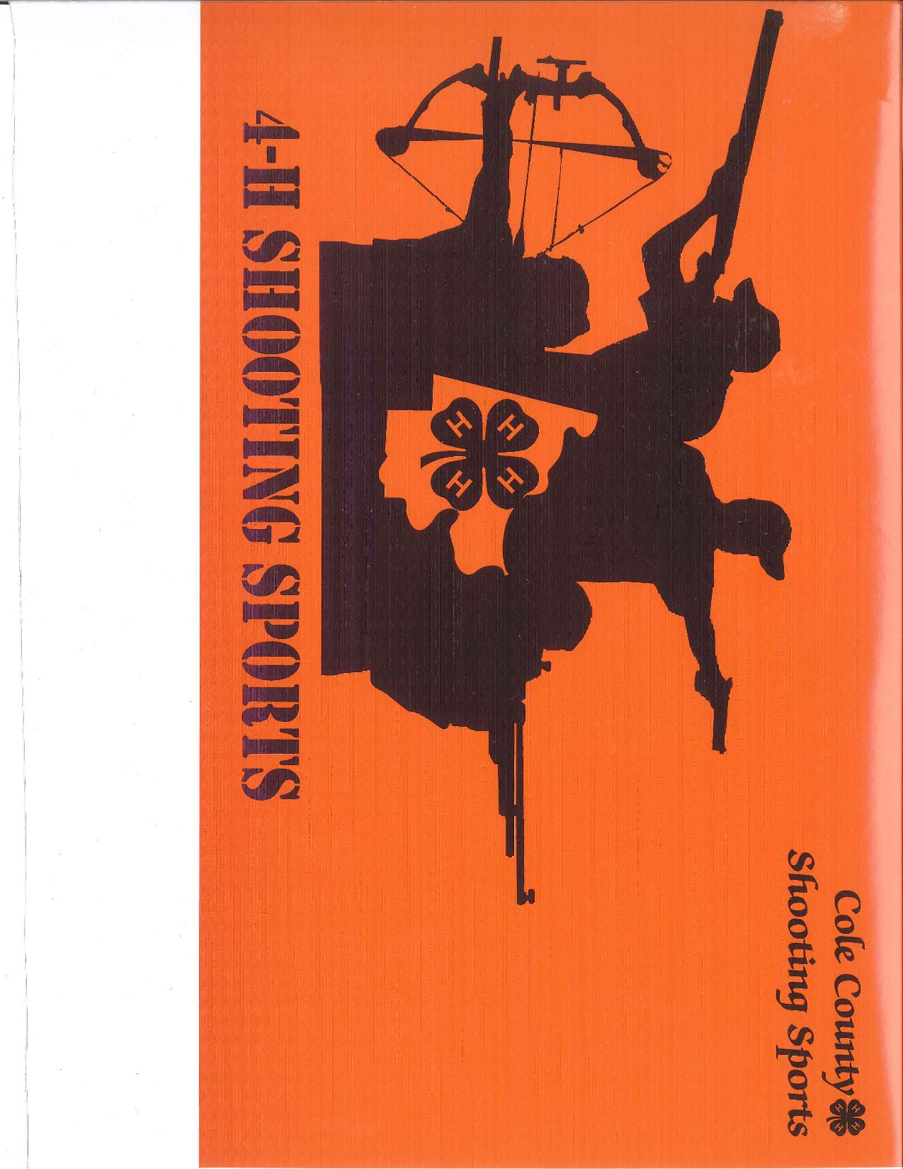
Front left chest area

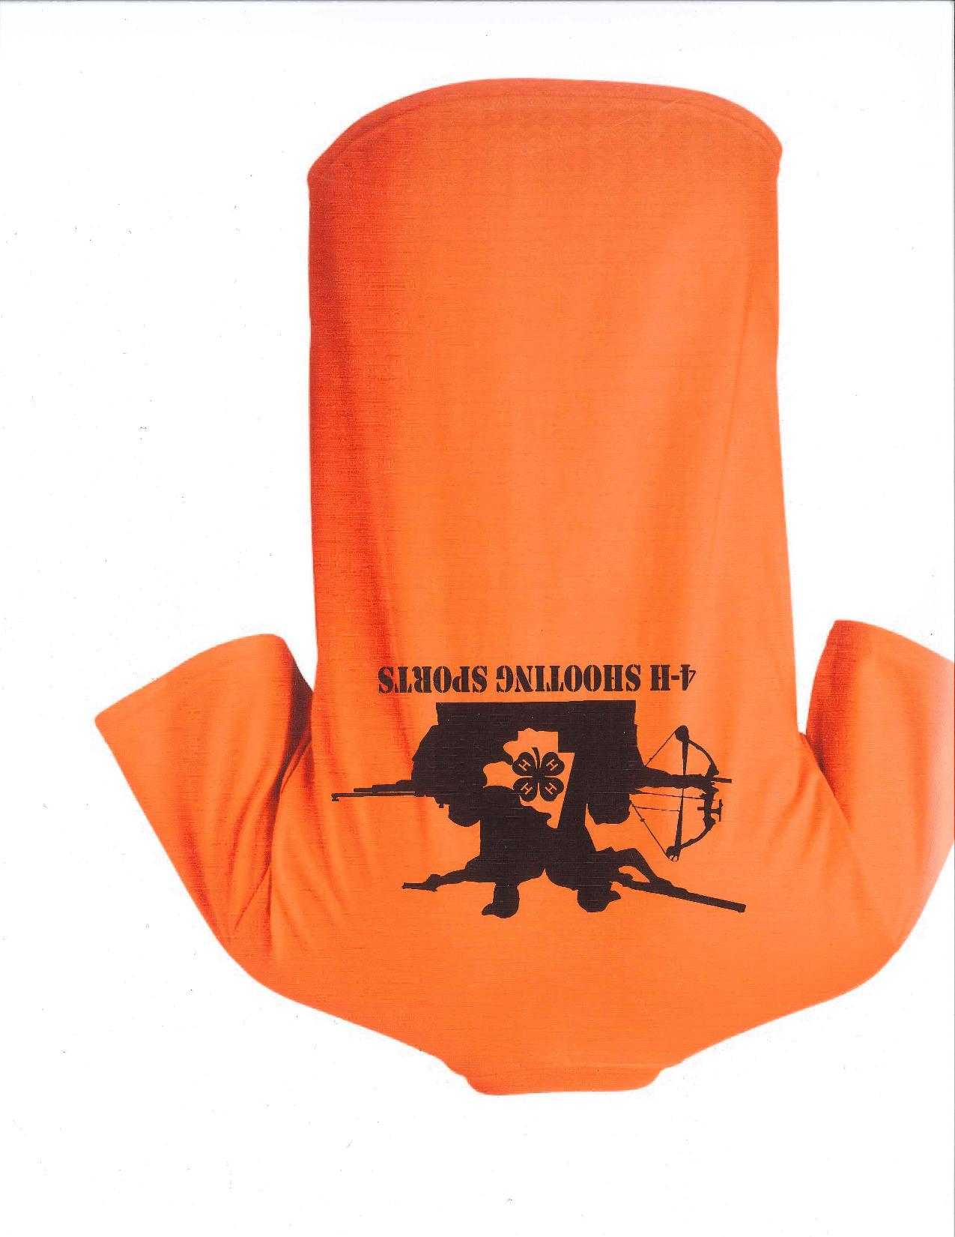
Cole County 4-H Shooting Sports
Back of shirt
2020 Shirt Order Form
1 form per family
Due April 1, 2020-
No shirts will be order after!

Family Name: ________________________________________________
Discipline: ___________________________________________________

 |  | Cotton  T-shirt |  |  | Hoodie |  | Sport-wicking shirt |  | Polo
Size |  | Price |  | Qty | Price | Qty | Price | Qty | Price Qty |  |  |  |  | Total
 |  |  | YOUTH
 | Small | $12 |  |  | $26 |  | $14 |  | $17
 | Medium | $12 |  |  | $26 |  | $14 |  | $17
 | Large | $12 |  |  | $26 |  | $14 |  | $17
 |  |  | ADULT
 | Small | $12 |  |  | $26 |  | $14 |  | $17
 | Medium | $12 |  |  | $26 |  | $14 |  | $17
 | Large | $12 |  |  | $26 |  | $14 |  | $17
 | XL | $12 |  |  | $26 |  | $14 |  | $17
 | XXL | $14 |  |  | $28 |  | $16 |  | $19
 | XXX & up | $16 |  |  | $30 |  | $18 |  | $21
FOR OFFICE USE ONLY! |  |  |  |  |  |  |  |  |  | Grand Total
Date Rcvd: ______________ Rcvd By: ______________
Amount: $______________
□ Cash □ Check #_________ □ Credit Card (over)
Financial Aid available |  |  |  |  |  |  |  |  |  |  | Due: April 1, 2020  (no shirts will be ordered after this time)


Cole County Extension
2436 Tanner Bridge Road
Jefferson City, MO 65101
573-634-2824

Credit Card Payment/Refund Authorization Form
Sign and complete this form to authorize Cole County Extension to make a one-time debit/credit to your credit card listed below.

By signing this form you give us permission to debit/credit your account for the amount indicated. This is permission for a single transaction only, and does not provide authorization for any additional unrelated debits or credits to your account.

Please complete the information below:

I ____________________________ authorize Cole County Extension to charge my credit card
(full name)
account indicated below for _____________ on or after ___________________. This payment is for
(amount) (date)

__4-H Shooting Sports Shirt/Cap Order_____.
(description of goods/services)

Billing Address ____________________________ Phone# ________________________
City, State, Zip ____________________________ Email ________________________
SIGNATURE _________________ DATE
I authorize the above named business to charge the credit card indicated in this authorization form according to the terms outlined above. This payment authorization is for the goods/services described above, for the amount indicated above only, and is valid for one time use only. I certify that I am an authorized user of this credit card and that I will not dispute the payment with my credit card company; so long as the transaction corresponds to the terms indicated in this form.

4-H:__Shooting Sports_________________
Business: ____________________________
Fall Festival: __________________________
Horticulture: _________________________
MG: ________________________________

Nutrition: ______________________________
Other: _________________________________
Publication: _____________________________
Soil Test: _______________________________

Account Type: Visa MasterCard AMEX Discover
Cardholder Name _________________________________________________
Account Number _____________________________________________
Expiration Date ____________
This extension center will NOT accept this authorization form by email. BUT we will accept it by:
- Fax: 573-634-5463
- Mail: 2436 Tanner Bridge Road, Jefferson City, MO 65101
- Phone: 573-634-2824

