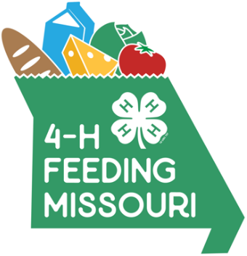
News release
4-H Feeding Missouri Food Drive
[insert county or club name here]
Many Missouri families face food insecurity. This means they struggle to put enough food on their tables. Missouri 4-H is continuing its partnership with Feeding Missouri and Missouri Farmers Care Drive to Feed Kids to not only educate about this issue, but to do something about it.
All of the state’s more than 1,600 4-H clubs, serving youth ages 5 to 18, are invited to participate in this year’s friendly competition among counties to donate the most meals through donations of volunteer hours, food and monetary contributions. As a state, we have a goal of raising 800,000 [update goal] meals by April 30, 2022 [update year].
Here’s how [INSERT NAME of CLUB] is contributing to the goal of raising half a million meals for food banks and pantries statewide!
Who: e.g., [NAME of 4-H Club, name and contact information for club leader or parent volunteer.]
What: 4-H Feeding Missouri food drive. [Insert brief but full description of your event here. Below is a made-up example to give you an idea of what to include.]
[Example only]
The [NAME 4-H of Club] will be volunteering at the [NAME of food pantry or organization] as part of our county’s participation in the statewide 4-H Feeding Missouri food drive. Youth ages 5 to 18 will bring in donations they have collected so far and help pantry staff sort and pack give-away boxes. Youth will be available to interview about the food drive and the impact of hunger in [NAME] County.
Where: [Exact name and address of location.]
When: [Exact times people will be doing the activity.]
Why: To help fill the shelves of our local food pantry and spread awareness of how widespread hunger is in Missouri.
It's all about Missourians helping Missourians fight hunger.

